**INTELLIGENT SOLAR INVERTER**

**A Project Report**

*Submitted By*

# AKHILA ROSE SABU (KTE17EE007)

# ANAGHA SIBY (KTE17EE012)

# ASHWIN GEORGE (KTE17EE024)

# EMMANUEL JOY (KTE17EE028)

# *to*

**APJ ABDUL KALAM TECHNOLOGICAL UNIVERSITY**

*in partial fulfillment for the award of the degree*

**BACHELOR OF TECHNOLOGY**

*in*

**ELECTRICAL AND ELECTRONICS ENGINEERING**

**DEPARTMENT OF ELECTRICAL & ELECTRONICS ENGINEERING**

# RAJIV GANDHI INSTITUTE OF TECHNOLOGY KOTTAYAM

**VELLOOR - 686501**

# JUNE 2021

# DEPARTMENT OF ELECTRICAL ENGINEERING

# RAJIV GANDHI INSTITUTE OF TECHNOLOGY KOTTAYAM

**VELLOOR, KOTTAYAM - 686501**

**www.rit.ac.in**



**CERTIFICATE**

# *This is to certify that this project report entitled “INTELLIGENT SOLAR INVERTER” is a bonafide record of the project presented by Ms. AKHILA ROSE SABU (KTE17EE007), Ms. ANAGHA SIBY (KTE17EE012), Mr. ASHWIN GEORGE (KTE17EE024), and Mr. EMMANUEL JOY (KTE17EE028) to APJ Abdul Kalam Technological University in partial fulfillment of the requirements for the award of Degree of Bachelor of Technology in Electrical & Electronics Engineering, is a bonafide record of the Project carried out by this team under our guidance and supervision. This report in any form has not been submitted to any other University or Institute for any purpose.*

**Prof. Sreelekha V.** **Dr. Prince A.** **Dr. Manju B.**

Project Guide Project Coordinator Head of the Department

**ACKNOWLEDGEMENT**

The contentment and euphoria that accompany the successful completion of any task would not be complete without the mention of people who have helped to make it possible. First and foremost, we thank God Almighty for his abundant blessings without which we would not be able to complete this project.

We sincerely thank *Dr. Jalaja M.J.*, the Principal of Rajiv Gandhi Institute of Technology, Kottayam and *Dr. Manju. B.*, the Head of the Department of Electrical Engineering, for providing us with the best facilities and atmosphere for the completion of our project.

We are indebted to our guide *Prof.* *Sreelekha V.*, Assistant Professor, project guide as well as our project coordinator *Dr. Prince A*., Associate Professor of Electrical Engineering Department who continually and convincingly conveyed a spirit of adventure in regard to our final year project and excitement in the goodwill to conduct the study. We also take this opportunity to thank all other staff members of the Electrical Department for their help and support.

We are especially grateful to our classmates for their assistance, criticisms and useful insights. Finally, this project would have not been possible without the confidence, endurance and support of our family. Our family has always been a source of inspiration and acknowledgement.

AKHILA ROSE SABU

ANAGHA SIBY

RIT, Kottayam ASHWIN GEORGE

June 2021 EMMANUEL JOY

**ABSTRACT**

The present trend of growing energy needs, increasing environmental concern and reduced supply of conventional fuels, alternatives to the use of non-renewable and polluting fossil fuels have to be investigated. One such alternative is solar energy which is free, renewable, and produces little environmental impact. The aim of this project is to design and construct a Maximum Power Point Tracking (MPPT) Based Solar Powered Inverter for standalone applications. The designed output is 160 Watts at 230V AC. The MPPT algorithm that we have used to harness maximum power from the solar module is Perturb and Observe (P & O). With the help of a boost converter, the output voltage from the solar panel is boosted to 12V using the MPPT algorithm implemented at the MOSFET gate of the boost converter. The next stage consists of a 12 V battery which stores the energy produced with the aid of a charge controller. The battery can serve as a buffer for ensuring continuous output to meet the required AC/DC loads. The 12V DC is converted to 8V AC with the help of a full-bridge (H-bridge) inverter and the transformer steps up the voltage to 230V AC which produces the requisite output for the load. The switching pulses for inverter switches are generated by the Arduino module using MOSFET gate driver and the gate pulses generated by Arduino are varied depending upon the feedback, the duty cycle is adjusted with respect to amplitude modulation and this will ensure a constant voltage across the load. Since this project is designed for low power applications, MOSFET is desirable and is used as the switches.

*Keywords: MPPT, MOSFET GATE DRIVER, H-BRIDGE, AMPLITUDE MODULATION, H-BRIDGE*

**CONTENTS**

|  |  |
| --- | --- |
| **ACKNOWLEDGEMENT** | i |
| **ABSTRACT** | ii |
| **LIST OF FIGURES** | vii |
| **LIST OF TABLES** | ix |
| **ABBREVIATIONS** | x |
| **NOTATIONS** | xi |
| **1. INTRODUCTION** | 1 |
| 1.1 Chapter Overview | 1 |
| 1.2 Project Background | 2 |
| 1.3 Problem Statements | 2 |
| 1.4 Project Objectives | 3 |
| **2. LITERATURE REVIEW** | 4 |
| 2.1 Chapter Overview | 4 |
| 2.2 Mode of Operation of Solar PV-System | 4 |
| 2.3 Types of Solar Inverter | 4 |
| 2.3.1 Stand Alone Inverters | 5 |
| 2.3.2 Grid-tie Inverters | 5 |
| 2.3.3 Battery Back-up Inverters | 5 |
| 2.4 PWM Modulation | 5 |
| 2.5 PWM Technique for Inverter | 6 |
| 2.5.1 Sine Wave Inverter | 6 |
| 2.6 Inverter Topologies | 7 |
| 2.6.1 Push Pull Topology | 8 |
| 2.6.2 H-Bridge Topology | 8 |
| 2.7 Solar Panel | 10 |
| 2.8 Power Electronic Switches | 11 |
| 2.8.1 IGBT | 11 |
| 2.8.2 MOSFET | 11 |
| 2.9 MOSFET Gate Driver – IR2110 | 12 |
| 2.9.1 Bootstrap Circuit | 14 |
| 2.10 Charge Controller | 12 |
| 2.10.1 Incremental Conductance Algorithm | 15 |
| 2.10.2 Constant Voltage Method | 16 |
| 2.10.3 Perturb and Observe Algorithm | 16 |
| 2.11 DC-DC Converter | 17 |
| 2.11.1 Buck Converter | 17 |
| 2.11.2 Buck Boost Converter | 18 |
| 2.11.3 Boost Converter | 19 |
| 2.12 Battery | 20 |
| 2.13 Transformer | 21 |
| 2.14 Arduino | 21 |
| 2.15 Raspberry Pi | 22 |
| **3. MPPT BASED SOLAR INVERTER** | 23 |
| 3.1 Chapter Overview | 23 |
| 3.2 Basic Principle of Solar Inverter | 23 |
| 3.3 Block Diagram | 23 |
| 3.4 Applications | 25 |
| 3.5 Advantages | 25 |
| 3.6 Disadvantages | 26 |
| **4. SELECTION AND DESIGN OF COMPONENTS** | 27 |
| 4.1 Chapter Overview | 27 |
| 4.2 Component Selection and Design | 27 |
| 4.2.1 Solar Panel | 27 |
| 4.2.2 Boost Converter | 28 |
| 4.2.3 Battery Sizing | 29 |
| 4.2.4 LC Filter | 29 |
| 4.2.5 Inverter | 29 |
| 4.2.6 Bootstrap Circuitry | 30 |
| 4.2.7 Diode | 31 |
| 4.2.7 Arduino Uno | 31 |
| 4.2.8 Arduino Nano | 32 |
| 4.3 Software Selection | 33 |
| 4.3.1 MATLAB | 34 |
| 4.3.2 Proteus | 34 |
| 4.3.3 Arduino IDE | 35 |
| 4.4 Cost Estimation | 35 |
| **5. SIMULATION STUDIES AND RESULTS** | 37 |
| 5.1 Chapter Overview | 37 |
| 5.2 Simulation of Gate Pulses | 37 |
| 5.3 Simulation of Gate Driver Circuitry | 38 |
| 5.3 Simulation of PV Panels | 39 |
| 5.4 Simulation of Inverter Circuit | 39 |
| 5.5 Simulation of the Proposed System | 41 |
| 5.6 Simulation Analysis | 42 |
| **6.** **HARDWARE IMPLEMENTATION AND OUTPUTS** | 43 |
| 6.1 Chapter Overview | 43 |
| 6.2 Battery | 43 |
| 6.3 Voltage Regulator | 43 |
| 6.4 Gate Pulse Generation | 43 |
| 6.5 Gate Driver | 44 |
| 6.6 Surface Mount Device | 44 |
| 6.7 PCB Designing | 44 |
| 6.8 Heat Sink | 47 |
| 6.9 Transformer | 48 |
| 6.10 Inverter | 48 |
| 6.10.1 Working | 48 |
| 6.10.2 Hardware Implementation | 49 |
| 6.10.3 Testing the Inverter on Load | 51 |
| 6.11 Output | 51 |
| **7. CONCLUSIONS** | 52 |
| 7.1Scope for the Future | 53 |
| **REFERENCES** | 54 |
| **APPENDIX I** | 55 |
| **APPENDIX II** | 56 |
| **APPENDIX III** | 60 |
| **APPENDIX IV** | 62 |
| **APPENDIX V** | 63 |
| **APPENDIX VI** | 66 |

**LIST OF FIGURES**

|  |  |
| --- | --- |
| 2.1 Pulse Generation Using PWM | 5 |
| 2.2 Sine Wave Inverter | 7 |
| 2.3 Push Pull Topology for Square Wave Inverter | 8 |
| 2.4 Switch Closing State | 8 |
| 2.5 H-bridge Topology | 9 |
| 2.6 Solar Panel | 10 |
| 2.7 An IGBT Switch | 11 |
| 2.8 Gate Charge Waveform | 12 |
| 2.9 Functional Block Diagram of IR2110 | 13 |
| 2.10 Bootstrap Circuitry | 14 |
| 2.11 Flowchart of MPPT Algorithm | 17 |
| 2.12 Buck Converter Circuit | 18 |
| 2.13 Buck Boost Converter Circuit | 19 |
| 2.14 Schematic Diagram of Boost Converter | 19 |
| 2.15 Waveforms of Boost Converter | 20 |
| 2.16 Lead Acid Battery | 20 |
| 2.17 Single-Phase Transformer | 21 |
| 2.18 Raspberry Pi | 22 |
| 3.1 Block Diagram of Solar Inverter | 23 |
| 4.1 Arduino Uno | 31 |
| 4.2 Arduino Nano | 32 |
| 4.3 Proteus Window | 34 |
| 5.1 SPWM Gate Pulses | 37 |
| 5.2 MOSFET Gate Driver Circuitry | 38 |
| 5.3 Amplified MOSFET Gate Driver Circuitry | 38 |
| 5.4 PV Panel Characteristics | 39 |
| 5.5 MATLAB Simulation of Inverter Circuit | 40 |
| 5.6 MATLAB Simulation Output | 40 |
| 5.7 Inverter circuit with Integrated MPPT | 41 |
| 5.8 Panel Output | 41 |
| 5.9 Inverter Output | 42 |
| 6.1 L7805-Voltage Regulator | 43 |
| 6.2 Arduino Output (SPWM Gate Pulses) | 43 |
| 6.3 IR2110-Gate Driver | 44 |
| 6.4 Surface Mount Device | 44 |
| 6.5 PCB Soldering | 46 |
| 6.6 Heat Sink | 47 |
| 6.7 Block Diagram of the Inverter | 48 |
| 6.8 H-bridge Inverter | 49 |
| 6.9 Pin-Diagram of IR2110 | 49 |
| 6.10 Hardware Circuit Diagram | 50 |
| 6.11 Load Voltage | 51 |

**LIST OF TABLES**

|  |  |  |
| --- | --- | --- |
| I | Parameters of Bootstrap Circuit | 30 |
| II | Technical Specifications of Arduino Uno | 32 |
| III | Technical Specifications of Arduino Nano | 33 |
| IV | Cost Estimation | 36 |
| V | Components Required | 55 |

**ABBREVIATIONS**

MPPT Maximum Power Point Tracking

P&O Perturb and Observe

H-BRIDGE Hybrid Bridge

AC Alternating Current

DC Direct Current

SOC State of Charge

VA Volt-Ampere

SMD Surface Mount Device

MSW Modified Square Wave

PV Photo-Voltaic

SPWM Sine Pulse Width Modulation

THD Total Harmonic Distortion

VFD Variable Frequency Drives

MOS Metal-Oxide Semiconductor

SCC Solar Charge Controller

SMPS Switch Mode Power Supply

CCM Continuous Conduction Mode

DCM Discontinuous Conduction Mode

SBC Single Board Computers

IDE Integrated Development Environment

SMT Surface Mount Technology

RF Radio Frequency

NiMH Nickel Metal Hydride

TTL Transistor-Transistor Logic

**NOTATIONS**

µ Micro

Wp Watt-peak

n Nano

m Milli

F Farad

H Henry

Wh Watt-hour

Ah Ampere-Hour

∆I Current Ripple

∆V Voltage Ripple

FSW Switching Frequency

**CHAPTER 1**

**INTRODUCTION**

Solar energy, the best source of non-conventional energy sources that reaches the earth, exceeds by far humankind’s needs. It is renewable and sustainable. Reducing dependence on fossil fuels and cutting down carbon emissions is one of the most important aspects of solar energy. It can make any country, especially tropical ones like India, self-sufficient in energy. India’s energy consumption in 2012 was 100 GW out of which 1GW was Solar energy. Ambitious projects like the National Solar Mission aiming at producing 20GW by 2020 are big steps towards progress. Rural areas are now lit up with solar lamps. Solar parks are also an emerging trend with Charanka Solar Park, Gujarat producing 20MW of energy. The government is also taking initiatives to encourage people to make use of the sun by subsidizing electricity bills for consumers using solar panels. So, if one makes more energy than one uses, one will end up in a profit without even burning a calorie!

Due to the nature of solar energy, two components are required to have a functional solar energy generator. These two components are a collector and a storage unit. The collector simply collects the radiation that falls on it and converts a fraction of it to other forms of energy (either electricity and heat or heat alone). The storage unit is required because of the non-constant nature of solar energy; at certain times only a very small amount of radiation will be received. At night or during heavy cloud cover, for example, the amount of energy produced by the collector will be quite small. The storage unit can hold the excess energy produced during the 2 periods of maximum productivity, and release it when the productivity drops. In practice, a backup power supply is usually added, for the situations when the amount of energy required is greater than both what is being produced and stored in the container.

* 1. **CHAPTER OVERVIEW**

This chapter discusses the foremost scheme of this project and observes a larger sketch on the problem with the current technologies, the area that will cover this project domain, and the milestones to achieve in this project. The chapter is divided into some categories that are project background to describe the reasons to carry out this project, problem statements to inform about the issues or weakness of the existing technology, objective to make sure what this project must achieve, and scope of this project.

**1.2 PROJECT BACKGROUND**

Conventional and non-conventional are the two sources of power generation. In today’s scenario, to generate most of the electrical power conventional sources like coal, gas, nuclear power generators are used. Most of the conventional sources are polluting the environment in the process of generating electricity. For example, nuclear energy is not much preferable because of its perishable nature and harmful radiation effect on mankind. Considering the current trend of exploitation of conventional sources, they will not be sufficient enough to fulfil the future requirements of mankind. Hence, a part of the electrical power should be generated by non-conventional energy sources like solar, wind and so on. Conventionally, there are two ways in which electrical power is transmitted. Direct current (DC) comes from a source of constant voltage and is suited to short-range or device level transmission. Alternating current (AC) power consists of a sinusoidal voltage source in which a continuously changing voltage (and current) can be used to employ magnetic components. Long-distance electrical transmission favours AC power since the voltage can be boosted easily with the use of transformers. By boosting the voltage, less current is needed to deliver a given amount of power to a load, reducing the resistive loss through conductors. The adoption of AC power has created a trend where most devices adapt AC power from an outlet into DC power for use by the device. However, AC power is not always available and the need for mobility and simplicity has given batteries an advantage in portable power. Thus, for portable AC power, inverters are needed. Inverters take a DC voltage from a battery or a solar panel as input and convert it into an AC voltage output.

**1.3 PROBLEM STATEMENT**

Inverters need a power source (battery) and generally, the battery is powered using conventional sources of energy which are both harmful to the environment and are expensive. Sometimes it is a cumbersome procedure to facilitate the generation of electrical power at isolated locations. Solar-based battery charging offers a solution to this problem and incorporation of the MPPT ensures maximum efficiency. Inverters with sine-wave topology enable DC-AC conversion to meet the desired AC loads. Conventional solar inverters are very expensive, less efficient, inflexible with parts and accessories, and are generally not feasible for portability. Hence, an inverter that is affordable with improved efficiency and favours portability which can be dismantled and assembled upon the requirement offers a convenient feature in day to day lives. A solar inverter with MPPT technology offers a convenient solution to the present problems that are discussed in the above statements.

**1.4 PROJECT OBJECTIVES**

This project mainly aims for the following.

* To develop an energy source that is renewable, free and environmentally friendly.
* To design an appropriate boost converter that would convert low DC voltages produced by PV array to a voltage level suitable for the battery.
* To harvest maximum available solar energy using MPPT technology.
* To incorporate a PV module, battery and inverter to feed the AC load.
* To charge a battery when there is excess power available after feeding the load or when load is absent.
* To design an inverter that converts the DC voltage to AC voltage.
* To design an AC filter that absorbs voltage/current ripples generated by the inverter.
* To provide a closed loop network to maintain a constant output voltage during variable loads.
* To minimize Total Harmonics Distortion (THD).

**CHAPTER 2**

**LITERATURE REVIEW**

**2.1 CHAPTER OVERVIEW**

For the implementation of this project, studies were conducted on the prospect of the solar inverters from sources including journals, IEEE papers, books, articles and others. A detailed explanation of topics relevant for the project such as solar panels, inverter topology, charge controller, solar PV system, PWM technique, battery, DC-DC converters, MOSFET, gate driver, transformer and Arduino are provided below.

**2.2 MODE OF OPERATION OF SOLAR PV SYSTEM**

The two modes of operation of solar PV system are:

* ON grid solar PV system
* OFF grid solar PV system

The On-grid system comprises mainly an inverter and a power meter and is capable of measuring power going in both directions, from the grid to our house and vice versa. If the solar panels installed in the residential area or work field produce more solar electricity than the required load, then the surplus power is fed into the grid and vice versa happens when enough power is not produced by panels. This type of system is installed in areas of high energy demand.

The Off-grid system mainly consists of an inverter and a battery to compensate for the voltage and power variations and to provide supply during non-sun shine hours. It is usually used to power remote areas. This system is cheaper than on grid system and has a superior performance ratio, yield factor and capacity factor. We have used an off-grid solar PV system in our project because of its advantages over the other [4] [1].

**2.3 TYPES OF SOLAR INVERTER**

Solar inverters may be classified into three broad types.

1. Stand Alone Inverters

2. Grid Tie Inverters

3. Battery Backup Inverters.

**2.3.1 STAND ALONE INVERTERS**

Stand-alone inverters, used in isolated systems where the inverter draws its DC energy from batteries charged by photovoltaic arrays. Many stand-alone inverters also incorporate integral battery chargers to replenish the battery from an AC source, when available. Normally these do not interface in any way with the utility grid, and as such, are not required to have anti-islanding protection.

**2.3.2 GRID TIE INVERTERS**

Grid-tie inverters, which match phase with a utility-supplied sine wave. Grid-tie inverters are designed to shut down automatically upon loss of utility supply, for safety reasons. They do not provide backup power during utility outages.

**2.3.3 BATTERY BACKUP INVERTERS**

Battery backup inverters are special inverters which are designed to draw energy from a battery, manage the battery charge via an onboard charger, and export excess energy to the utility grid. These inverters are capable of supplying AC energy to selected loads during a utility outage, and are required to have anti-islanding protection.

**2.4 PULSE WIDTH MODULATION**

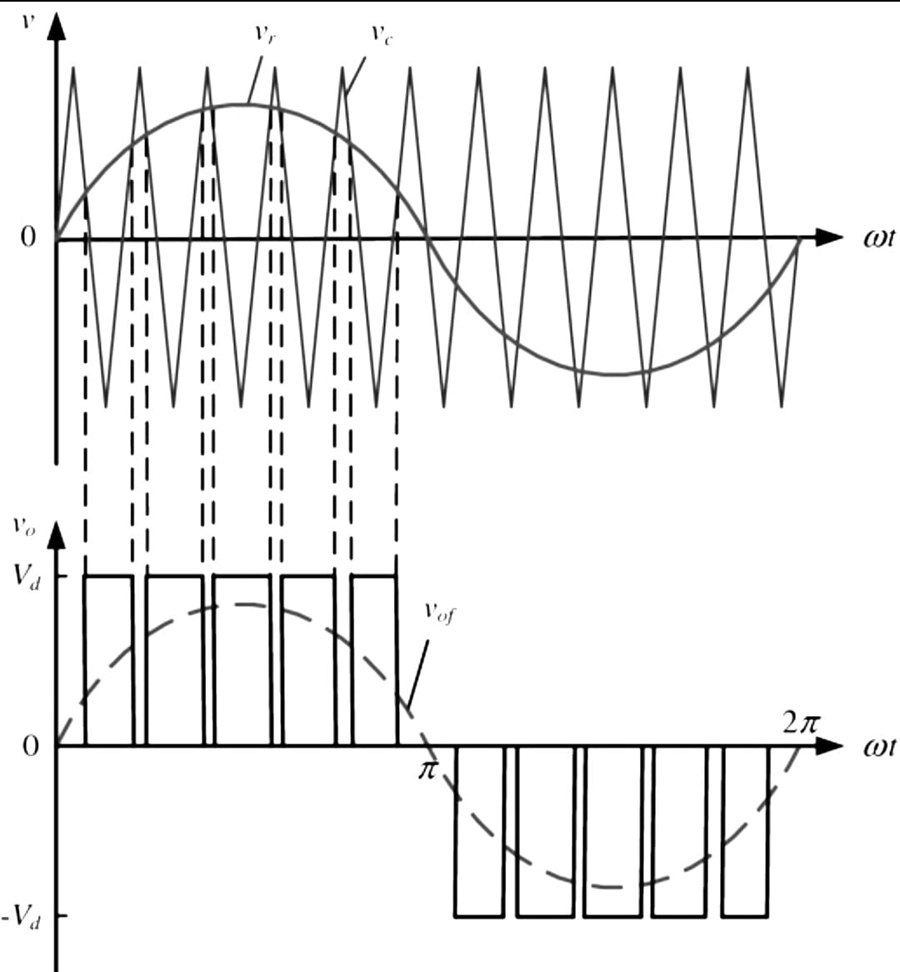Pulse-width modulation (PWM) is a method of reducing the average power delivered by an electrical signal, by effectively chopping it up into discrete parts. The average value of [voltage](https://en.wikipedia.org/wiki/Volt) (and [current](https://en.wikipedia.org/wiki/Electric_current)) fed to the [load](https://en.wikipedia.org/wiki/Electrical_load) is controlled by turning the switch between supply and load on and off at a fast rate. The longer the switch is on compared to the off periods, the higher the total power supplied to the load. In PWM, the width of each pulse is varied in proportion to the amplitude of a sine wave evaluated at the Centre of the same pulse. It is used to generate gating pulses for MOSFET switching action. The advantage of PWM is that the distortion factor and lower order harmonics can be reduced significantly. Here, the gating signals are generated by comparing a sinusoidal reference signal with a triangular carrier wave of frequency *fc* and it is shown in Figure 2.1. The frequency of reference signal *fr*, determines the inverter output frequency and its peak amplitude *Vm*, controls the modulation index *MI*, and RMS output voltage *VO*. In Sinusoidal pulse width modulation (SPWM), amplitudes of the triangular wave (carrier) and sine wave (modulating) are compared to obtain PWM waveform.

Figure 2.1: Pulse Generation using PWM

**2.5 PWM TECHNIQUE FOR INVERTER**

The classification of inverters based on PWM technique are:

* Square Wave Inverters
* Modified Square Wave Inverters
* Sine Wave Inverters

Square wave inverter is the simplest and the cheapest of inverters. In comparison with a sine wave inverter, the output of such an inverter is in the form of a square wave and can be with or without feedback. The output waveform of square inverters without feedback has high total harmonic distortion (THD) and voltage or frequency controlling is not possible here. Most electronic equipment will not operate correctly from the square wave switching and produces a buzzing sound in some equipment. These inverters produce audio glitches and when used for charging, touchpad funkiness is observed [4].

Modified square wave (MSW) inverters are much more efficient than square wave inverters. In comparison to the square wave, MSW looks similar to a square that is thinned, separated and made taller. Considering the cost encountered, the MSW inverter lies closer to that of the square wave’s circuit. The major advantage of an MSW inverter is voltage regulation which is done using varying the pulse width and off periods. In audio systems, an MSW inverter produces noise to the signals but most of the equipment works properly with MSW topology.

Sine Wave Inverter is the ideal or the best among the three types of inverters mentioned here. All the electrical products available are engineered to operate efficiently with a sine wave AC power. The sine inverters provide the output as a substitute for the grid or utility supply [7].

**2.5.1 SINE WAVE INVERTER**

The AC power with fewer harmonics can be produced by sine inverter by employing the SPWM technique for the switches turning ’On’ and ’Off’. Among the push-pull and H-bridge topology, the H-bridge topology is mostly preferred in the manufacturing of sine wave inverter. In comparison to square wave inverters, which have a bulky size, noisy output voltage, and poor efficiency, sine wave inverters have small control circuits and higher efficiency. While powering the motor, the sine-wave inverter provides better performance because of little harmonic distortion and high surge capacity. This produces a pure sine wave that is ideal for the operation of all the equipment that is manufactured for an AC sine wave input. A typical Sine Wave Inverter with gate signals are shown in Figure 2.2.

**Advantages of Sine Wave Inverter**

* Good use of input DC voltage
* Linearity in the control of voltage
* Low switching losses
* Low amplitude for low order harmonics

Taking note of the above advantages, we had selected sine wave inverter topology for our project.

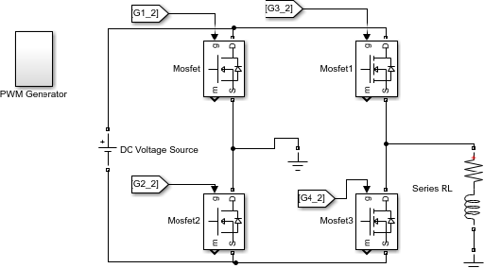

Figure 2.2: Sine Wave Inverter

**2.6 INVERTER TOPOLOGIES**

There are many topologies or circuit designs for creating higher power AC from low voltage DC sources. The different multilevel inverter topologies are Cascaded H-bridges converter, Diode clamped inverter, and Flying capacitor multilevel inverter. But the two common topologies used are the Push-Pull and H-Bridge.

**2.6.1 PUSH PULL TOPOLOGY**

This topology is suitable for producing square and modified square wave inverters. The basic theory of Push-Pull topology is shown in Figure 2.3. There are two transistor switches in this design. If the top switch closes, it will cause current to flow from the battery negative through the transformer primary to the battery positive. This induces a voltage in the secondary side of the transformer that is equal to the battery voltage times the turn’s ratio of the transformer.

This phenomena flow is shown in Figure 2.4 (a). Only one switch is closed at a time. The switches flip-flop after a period of approximately 8ms which is one-half of 60Hz AC cycle. The top switch opens and then the bottom switch closes allowing current to flow in the opposite direction as illustrated in Figure 2.4 (b). The continuation of the closed and open switch will produce a square wave output waveform which is higher voltage AC power. The addition of an extra winding in the transformer along with a few other parts allows output of a Modified Square Wave [4].

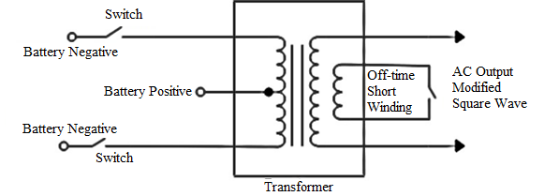

Figure 2.3: Push Pull Topology for Square Wave Inverter.

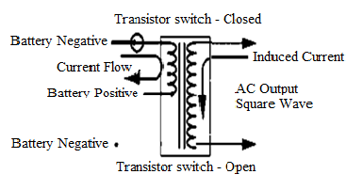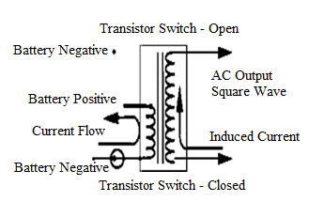

(b)

(a)

Figure 2.4: (a) Top switch closing state, (b) Bottom switch closing state

**2.6.2 H** – **BRIDGE TOPOLOGY**

The operation of H-Bridge topology is similar to Push-Pull topology. The term H-Bridge is derived from the typical graphical representation of such a circuit. It is simple and with the help of some filters pure sine waves can be obtained. This configuration allows the inverter to send & accept both real & reactive power. An H-Bridge is built with four transistor switches. The transistors are divided into four groups with the transformer primary connected across the middle of the bridge as illustrated in Figure 2.5 [4].

The transistors are switched on and off in a specific pattern to produce each part of the waveform. If the switch 1 and 4 are closed, current will flow from the battery negative through the transformer primary to the positive terminal of the battery. This current induces a current flow in the secondary of the transformer, which has a peak voltage equal to the battery voltage times the turn ratio of the transformer. The switch 1 and 4 open after a period of time and the switch 2 and 4 close providing off time shorting. The length of the on and off time is determined according to the Pulse Width Modulation (PWM) controller. Then, the switch 2 and 3 are close and allow current flow through the transformer in a direction opposite to the current flow. The switch 2 and 4 are closed after this cycle is complete for off time shorting. This cycle will continue to produce AC power. We used this topology in our project [4].

Advantage of using H bridge are:

* Magnetic cores are small.
* No gap of the magnetic path.
* Less stray magnetic field.
* Highly efficient**.**

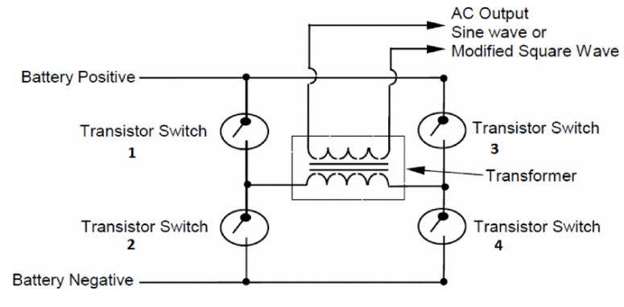

Figure 2.5: H-Bridge Topology

**2.7 SOLAR PANEL**

A solar panel, or [photo-voltaic](https://en.wikipedia.org/wiki/Photovoltaic) (PV) module, is an assembly of photo-voltaic cells mounted in a framework for installation. Solar panels use [sunlight](https://en.wikipedia.org/wiki/Sunlight) as a source of energy to generate direct current [electricity](https://en.wikipedia.org/wiki/Electricity). A collection of PV modules is called a PV panel, and a system of panels is an array. Arrays of a [photovoltaic system](https://en.wikipedia.org/wiki/Photovoltaic_system) supply [solar electricity](https://en.wikipedia.org/wiki/Solar_electricity) to electrical equipment. A single solar module can produce only a limited amount of power; most installations contain multiple modules adding voltages or current to the wiring and PV system.

The structural member of a module can either be the top layer or the back layer. The majority of modules use wafer- based crystalline silicon cells or thin-film cells based on cadmium telluride or silicon. The conducting wires that take the current off the panels may contain silver, copper or other non-magnetic conductive transition metals. The cells must be connected electrically to one another and to the rest of the system. Cells must also be protected from mechanical damage and moisture. Most solar panels are rigid, but semi flexible ones are available, based on thin-film cells. A typical picture of solar panel is shown below in the Figure 2.6.

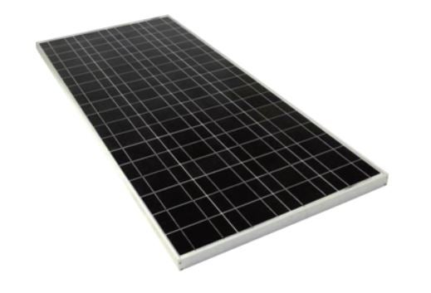

Figure 2.6: Solar panel

Nowadays many types of solar panels are available. The major types of solar panels are monocrystalline, polycrystalline, and thin-film. Each of these has their advantages and disadvantages. The efficiency of monocrystalline is around 20% and that of polycrystalline is approximately 15%. But the cost of monocrystalline is higher than polycrystalline. The efficiency of a module determines the area of a module given the same rated output. An 8% efficient 230W module will have twice the area of a 16% efficient 230 W module. We found that monocrystalline solar panels are effective for our project. So, we designed a monocrystalline panel for our use.

**2.8 POWER ELECTRONIC SWITCHES**

  A power electronic switching device is a combination of active switchable power semiconductor drivers that have been integrated into one. The main characteristics of the switch are determined by the internal correlation of functions and interactions of its integrated system.  
Power switching devices are normally selected based on the rating at which they handle power, that is, the product of their current and voltage rating instead of their power dissipation rate. Consequently, the major attractive feature in a power electronic switch is its capability to dissipate low or almost no power. As a result, the electronic switch able to achieve a low and continuous surge of power.

**2.8.1 IGBT**

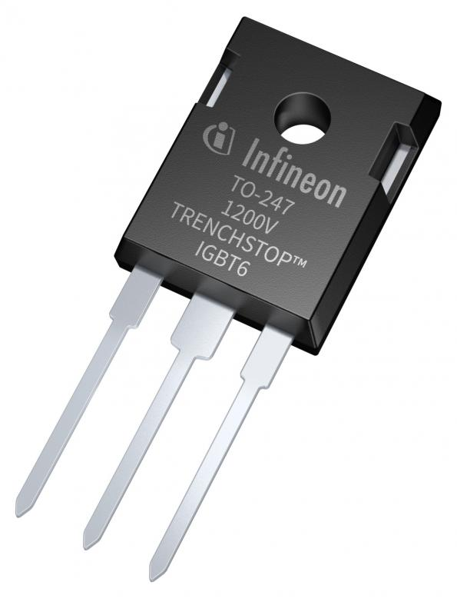An insulated-gate bipolar transistor (IGBT), shown in Figure 2.7 is a three-terminal [power semiconductor device](https://en.wikipedia.org/wiki/Power_semiconductor_device) primarily used as an electronic switch, which, as it was developed, came to combine high efficiency and fast switching. It consists of four alternating layers (P–N–P–N) that are controlled by a [metal–oxide–semiconductor](https://en.wikipedia.org/wiki/Metal%E2%80%93oxide%E2%80%93semiconductor) (MOS) [gate](https://en.wikipedia.org/wiki/Metal_gate) structure. Although the structure of the IGBT is topologically the same as a [thyristor](https://en.wikipedia.org/wiki/Thyristor) with a "MOS" gate ([MOS-gate thyristor](https://en.wikipedia.org/wiki/MOS-controlled_thyristor)), the thyristor action is completely suppressed, and only the [transistor](https://en.wikipedia.org/wiki/Transistor) action is permitted in the entire device operation range. It is used in [switching power supplies](https://en.wikipedia.org/wiki/Switching_power_supply) in high-power applications: [variable-frequency drives](https://en.wikipedia.org/wiki/Variable-frequency_drive) (VFDs), [electric cars](https://en.wikipedia.org/wiki/Electric_car), trains, variable-speed refrigerators, lamp ballasts, arc-welding machines, and air conditioners.

Figure 2.7: An IGBT switch

Since it is designed to turn on and off rapidly, the IGBT can synthesize complex waveforms with [pulse-width modulation](https://en.wikipedia.org/wiki/Pulse-width_modulation) and [low-pass filters](https://en.wikipedia.org/wiki/Low-pass_filter), so it is also used in [switching amplifiers](https://en.wikipedia.org/wiki/Switching_amplifier) in sound systems and industrial [control systems](https://en.wikipedia.org/wiki/Control_system). In switching applications modern devices feature [pulse repetition rates](https://en.wikipedia.org/wiki/Pulse_repetition_frequency) well into the ultrasonic-range frequencies, which are at least ten times higher than audio frequencies handled by the device when used as an analog audio amplifier. As of 2010, the IGBT is the second most widely used power transistor, after the [power MOSFET](https://en.wikipedia.org/wiki/Power_MOSFET)

**2.8.2 MOSFET**

The MOSFET is a three-terminal (gate, drain, and source) fully-controlled switch. The gate/control signal occurs between the gate and source, and its switch terminals are the drain and source. The gate itself is made of metal, separated from the source and drain using a metal oxide. This allows for less power consumption, and makes the transistor a great choice for use as an electronic switch or common-source amplifier. In order to function properly, MOSFETs have to maintain a positive temperature coefficient that is, the chance for thermal runaway is almost zero and the on-state losses are lower because of the transistors on state resistance and high frequency operation. They can perform fast switching applications with little turn-off losses.

When compared to the IGBT, a power MOSFET has the advantages of higher commutation speed and greater efficiency during operation at low voltages. It can also sustain a high blocking voltage and maintain a high current. So, Power MOSFET P55nf06 has been used for the implementation of the inverter circuit.

**Advantages of MOSFET:**

* Improved switching speeds.
* Improved dynamic performance that requires even less power from the driver.
* Lower gate-to-drain feedback capacitance.
* Lower thermal impedance which, in turn, has enabled much better power dissipation.
* MOSFET is cheaper compared to other switches.
* Lower rise and fall times has allowed operation at higher switching frequencies.

**2.9 MOSFET GATE DRIVER- IR2110**

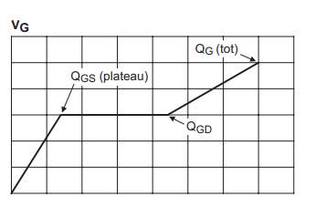A gate driver is a [power amplifier](https://en.wikipedia.org/wiki/Power_amplifier) that accepts a low-power input from a controller [IC](https://en.wikipedia.org/wiki/Integrated_circuit) and produces a high-current drive input for the gate of a high-power transistor such as an [IGBT](https://en.wikipedia.org/wiki/IGBT) or [power MOSFET](https://en.wikipedia.org/wiki/Power_MOSFET). Gate drivers can be provided either on-chip or as a discrete module Gate driver is an integral part for any high frequency DC-DC converters. Gate driver is required because, the PWM output from the microcontroller or any other controller may not have sufficient current sourcing or sinking capability to turn on and off the FET’s quickly. The Figure 2.8 shows how the MOSFET will turn on.

Figure 2.8: Gate charge waveform

In order to perfectly turn on any MOSFET we need to inject sufficient amount of charge into the gate of the device. This is mentioned as Qtot in the datasheet.

Then, $Q_{tot}=I_{g}×T_{sw}$

$${ I}_{g}=Q_{tot}×f_{sw}$$

So higher the switching frequency, higher the gate current required to turn on the device. That is why we require gate driver for high frequency application.

There are many types of gate drivers, IR2110 has been selected for this project. IR2110 is a high voltage MOSFET driver IC. It can drive both low side and high side switches in half-bridge and low bridge circuits. It has a floating circuit to handle bootstrap operation and can **withstand voltage** up to 500 V (offset voltage). Its output pins can provide a peak current of up to 2 amperes and can also be used as an IGBT driver. Because of its electrical features, it is highly recommended for pure sine wave inverters.

**Electrical Features:**

* Provide Gate voltage between 10-20 volts.
* The bootstrap operation operating range is +500V or +600V.
* Protection for Under-voltage for LO and HO pins/channels.
* Automatic shutdown with a feedback circuit.
* Synchronized propagation delay.

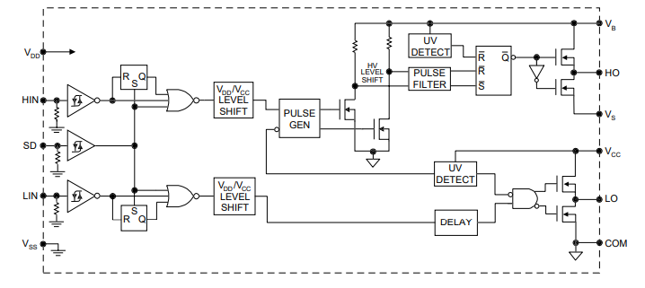

Figure 2.9: Functional Block Diagram of IR2110

From the Figure 2.9, we can deduce that IR2110 consist of two powerful output buffers. One for driving low side FET and other for driving high side FET. The input channel consist of two Schmitt triggers whose threshold voltage can be programmed by programming $V_{DD}$. The inputs are compatible with CMOS as well as TTL output from the microcontroller. An active high shutdown overrides the output in the presence of fault signal. The high side and low side channels are matched closely by adjusting the time delay.

**2.9.1 BOOTSTRAP CIRCUIT**

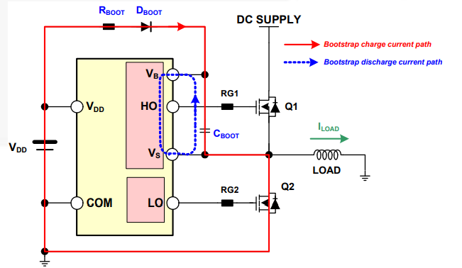The bootstrap circuit is useful in a high-voltage gate driver and operates as follows. When the VS goes below the IC supply voltage VDD or is pulled down to ground (the Low-side switch is turned ON and the High-side switch is turned OFF, the bootstrap capacitor, CBOOT, charges through the bootstrap resistor, RBOOT, and bootstrap diode, DBOOT, from the VDD power supply, as shown in Figure 2.10. This is provided by VBS when VS is pulled to a higher voltage by the High-side switch, the VBS supply floats and the bootstrap diode reverses bias and blocks the rail voltage (the Low-side switch is turned OFF and High-side switch is turned ON) from the IC supply voltage, VDD.

Figure 2.10: Bootstrap Circuitry

**2.10** **CHARGE CONTROLLER**

The regulation of energy flow to the solar home systems and inverter systems as well as in the PV hybrid systems is done by the solar charge controller (SCC). The main function SCC is to charge the battery and protect the electric cells from overcharging.

The main type of charge controller are:

* Simple ½ stage control
* PWM Controller
* MPPT Charge Controller

The simple 12 stage control (SCC) or ON-OFF controller has shunt transistors to regulate the voltage in one or two steps. This controller shorts the solar panels when a certain voltage arrives. No radio frequency (RF) interference is generated in this type of SCC. These SCCs cannot provide sustained high voltage equalization charges. Most of these controllers do not recharge quickly. Charging is a time-consuming process.

The PWM charge controllers are better than ON-OFF controllers and this SCC pulls down the output voltage from the solar array to near to that of battery nominal voltage. This SCC recharges batteries faster than the ON-OFF type of controller. PWM controller creates RF interference and more water loss is seen in PWM charged batteries

The MPPT controller which tracks and extracts the maximum power input from the PV module and produces a constant high DC voltage. This charge controller is the most efficient among the different types of SCC available. The MPPT controller adjusts the input voltage and harvests maximum power from the solar arrays that is, the controller identifies best working voltage and current of solar panel and matches that with the cell bank. Many types of algorithms are available and three of them are perturb and observe (P&O), Incremental conductance (IC) and Constant Voltage. This charge controller is opted for our project.

### **2.10.1 CONVENTIONAL INCREMENTAL CONDUCTANCE ALGORITHM**

In the incremental conductance method, the controller measures incremental changes in PV array current and voltage to predict the effect of a voltage change. This method requires more computation in the controller, but can track changing conditions more rapidly than the perturb and observe method (P&O). Unlike the P&O algorithm, it does not produce oscillations in power output. This method utilizes the incremental conductance (dI/dV{\displaystyle dI/dV}) of the photovoltaic array to compute the sign of the change in power with respect to voltage (dP/dV{\displaystyle dP/dV}).The incremental conductance method computes the maximum power point by comparison of the incremental conductance (∆I/∆V{\displaystyle I_{\Delta }/V_{\Delta }}) to the array conductance (I/V{\displaystyle I/V}). When these two are the same (I/V=∆I/∆V{\displaystyle I/V=I_{\Delta }/V_{\Delta }}), the output voltage is the MPP voltage. The controller maintains this voltage until the irradiation changes and the process is repeated.

The incremental conductance method is based on the observation that at the maximum power point dP/dV=0{\displaystyle dP/dV=0}, and that P=VI{\displaystyle P=IV}. The current from the array can be expressed as a function of the voltage: P=I(V)V {\displaystyle P=I(V)V}. Therefore, dP/dV=VdI/dV+I(V){\displaystyle dP/dV=VdI/dV+I(V)}. Setting this equal to zero yields: dI/dV=-I(V)/V{\displaystyle dI/dV=-I(V)/V}. Therefore, the maximum power point is achieved when the incremental conductance is equal to the negative of the instantaneous conductance. The characteristic of the power-voltage curve also shows that: when the voltage is smaller than the maximum power point, dP/dV>0{\displaystyle dP/dV>0}, so dI/dV>-I/V{\displaystyle dI/dV>-I/V}; when the voltage is bigger than the maximum power point, dP/dV<0{\displaystyle dP/dV<0} or dI/dV<-I/V{\displaystyle dI/dV<-I/V}. Thus, the MPP tracker can know where it is on the power-voltage curve by calculating the relation of the change of current/voltage and the current voltage themselves.

**2.10.2 CONSTANT VOLTAGE**

The term "constant voltage" in MPP tracking is used to describe different techniques by different authors, one in which the output voltage is regulated to a constant value under all conditions and one in which the output voltage is regulated based on a constant ratio to the measured open circuit voltage (VOC{\displaystyle V_{OC}}). The latter technique is referred to in contrast as the "open voltage" method by some authors. If the output voltage is held constant, there is no attempt to track the maximum power point, so it is not a maximum power point tracking technique in a strict sense, though it does have some advantages in cases when the MPP tracking tends to fail, and thus it is sometimes used to supplement an MPPT method. In the "constant voltage" MPPT method (also known as the "open voltage method"), the power delivered to the load is momentarily interrupted and the open-circuit voltage with zero current is measured. The controller then resumes operation with the voltage controlled at a fixed ratio, such as 0.76, of the open-circuit voltage, VOC{\displaystyle V_{OC}}. This is usually a value which has been determined to be the maximum power point, either empirically or based on modelling, for expected operating conditions. The operating point of the PV array is thus kept near the MPP by regulating the array voltage and matching it to the fixed reference voltage {\displaystyle V_{ref}=kV_{OC}}Vref=k VOC. The value of Vref {\displaystyle V_{ref}} may be also chosen to give optimal performance relative to other factors as well as the MPP, but the central idea in this technique is that {\displaystyle V_{ref}} Vref is determined as a ratio to VOC {\displaystyle V_{OC}}. One of the inherent approximations in the "constant voltage" ratio method is that the ratio of the MPP voltage to {\displaystyle V_{OC}} VOC is only approximately constant, so it leaves room for further possible optimization.

**2.10.3 PERTURB AND OBSERVE ALGORITHM**

The Perturb and Observe (P&O) algorithm is used to implement the MPPT. It is simple to implement with analogue and digital circuits, does not require previous knowledge of the PV generator characteristics or the measurement of solar intensity and cell temperature and can produce oscillations under the condition of steady state irradiance of the power output around the maximum power point. It adjust the input voltage and harvest maximum power from solar panel. It perturbs the operating point of the system causing the PV array terminal voltage to fluctuate around the MPP voltage even if the solar irradiance and the cell temperature are constants. It is 10 times faster than other type of algorithms. The MPPT charge controller is the most efficient & the response is improved because the control for the extracted power is optimized. The main advantages of P&O algorithms are simple structure and ease of implementation, with both stand-alone and grid-connected systems, MPPT can be done with very high efficiency but it has limitations that reduce efficiency of MPPT. The P&O flowchart is illustrated in the Figure 2.11.

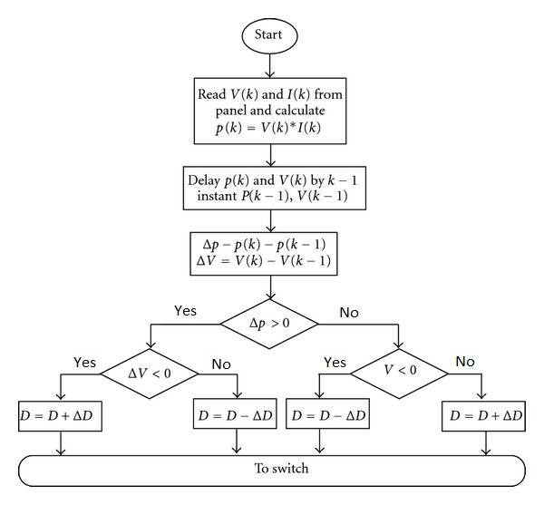

Figure 2.11: Flow Chart of MPPT Algorithm

**2.11 DC-DC COVERTER**

A DC-to-DC converter is an [electronic circuit](https://en.wikipedia.org/wiki/Electronic_circuit) or electromechanical device that converts a source of [direct current](https://en.wikipedia.org/wiki/Direct_current) (DC) from one [voltage](https://en.wikipedia.org/wiki/Voltage) level to another. It is a type of [electric power converter](https://en.wikipedia.org/wiki/Electric_power_conversion). Power levels range from very low (small batteries) to very high (high-voltage power transmission). Three types of commonly used converters are buck converter, buck boost converter and boost converter.

**2.11.1 BUCK CONVERTER**

A buck converter (step-down converter depicted in Figure 2.12) is a [DC-to-DC power converter](https://en.wikipedia.org/wiki/DC-to-DC_converter) which steps down voltage (while drawing less average current) from its input (supply) to its output (load). It is a class of [switched-mode power supply](https://en.wikipedia.org/wiki/Switched-mode_power_supply) (SMPS) typically containing at least two semiconductors (a [diode](https://en.wikipedia.org/wiki/Diode) and a [transistor](https://en.wikipedia.org/wiki/Transistor), although modern buck converters frequently replace the diode with a second transistor used for [synchronous rectification](https://en.wikipedia.org/wiki/Synchronous_rectification)) and at least one energy storage element, a [capacitor](https://en.wikipedia.org/wiki/Capacitor), [inductor](https://en.wikipedia.org/wiki/Inductor), or the two in combination. To reduce voltage ripple, filters made of capacitors (sometimes in combination with inductors) are normally added to such a converter's output (load-side filter) and input (supply-side filter). Switching converters (such as buck converters) provide much greater [power efficiency](https://en.wikipedia.org/wiki/Power_efficiency) as DC-to-DC converters than [linear regulators](https://en.wikipedia.org/wiki/Linear_regulator), which are simpler circuits that lower voltages by dissipating power as heat, but do not step up output current. Buck converters can be highly efficient (often higher than 90%), making them useful for tasks such as converting a computer's main (bulk) supply voltage (often 12 V) down to lower voltages needed by [USB](https://en.wikipedia.org/wiki/USB), [DRAM](https://en.wikipedia.org/wiki/DRAM) and the [CPU](https://en.wikipedia.org/wiki/Central_processing_unit) (5V, 3.3V or 1.8V).

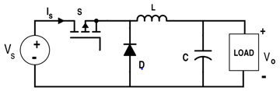

Figure 2.12: Buck converter circuit

**2.11.2 BUCK-BOOST CONVERTER**

The boost converter is a type of [DC-to-DC converter](https://en.wikipedia.org/wiki/DC-to-DC_converter) that has an output voltage magnitude that is either greater than or less than the input voltage magnitude. It is equivalent to a [flyback converter](https://en.wikipedia.org/wiki/Flyback_converter) using a single inductor instead of a transformer. The buck-boost converter is a combination of 2 different topologies. Both of them can produce a range of output voltages, ranging from much larger (in absolute magnitude) than the input voltage, down to almost zero. Here a buck(step-down) converter is combined with a boost(step-up) converter. The output voltage is typically of the same polarity of the input and can be lower or higher than the input. Such a non-inverting buck-boost converter may use a single inductor which is used for both the buck inductor mode and the boost inductor mode, using switches instead of diodes, sometimes called a “four switch buck-boost converter”, it may use multiple inductors but only a single switch as in the [SEPIC](https://en.wikipedia.org/wiki/SEPIC_converter) and [Cuk](https://en.wikipedia.org/wiki/%C4%86uk_converter) topologies. There are many applications, however, such as battery-powered systems, where the input voltage can vary widely, starting at full charge and gradually decreasing as the battery charge is used up. At full charge, where the battery voltage may be higher than needed by the circuit being powered, a buck regulator would be ideal to keep the supply voltage steady. However as the charge diminishes the input voltage falls below the level required by the circuit, and either the battery must be discarded or re-charged; at this point, the ideal alternative would be the boost regulator. A basic circuit diagram of a Buck-Boost Converter is shown in Figure 2.13.

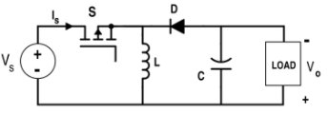

Figure 2.13: Buck-Boost Converter Circuit

**2.11.3 BOOST CONVERTER**

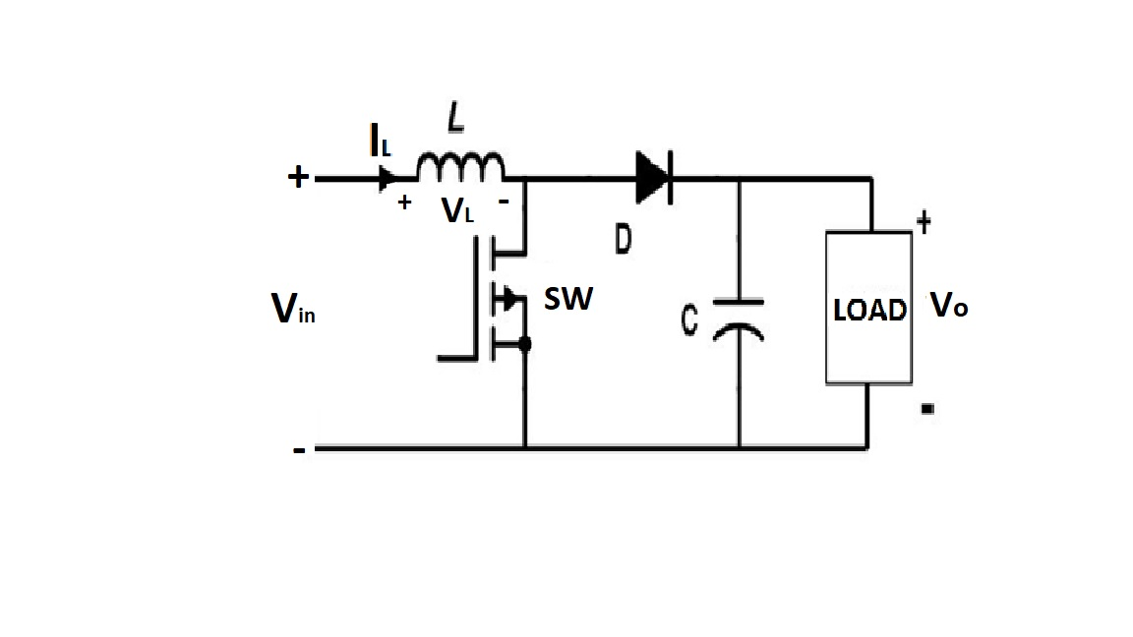A boost converter (step-up converter) is a [DC-DC power converter](https://en.wikipedia.org/wiki/DC-to-DC_converter) that steps up voltage (while stepping down current) from its input (supply) to its output (load). The boost converter is a medium of power transmission to perform energy absorption and injection from solar panel to battery. The process of energy absorption and injection in boost converter is performed by a combination of four components which are inductor, electronic switch, diode and output capacitor. The connection of a boost converter is shown in Figure 2.14.

Figure 2.14: Schematic diagram of boost converter

The process of energy absorption and injection will constitute a switching cycle. In other word, the average output voltage is controlled by the switching on and off time duration. At constant switching frequency, adjusting the on and off duration of the switch is called pulse width modulation (PWM) switching. The switching duty cycle, k is defined as the ratio of the on duration to the switching time period. The energy absorption and injection with the relative length of switching period will operate the converter in two different modes known as continuous conduction mode (CCM) and discontinuous conduction mode (DCM). The electronic switch SW has been chosen based on its voltage and current rating which have to be higher than the maximum input voltage and current. We tried to design a boost converter operated in CCM to step up a fluctuating solar panel voltage to a higher constant output voltage of 12V.

Under CCM, it is divided into two modes. Mode 1 begins when the switch SW is turned on at t = 0. The input current which rises flows through inductor L and switch SW. During this mode, energy is stored in the inductor and load is supplied by capacitor current. Mode 2 begins when the switch is turned off at t = kT. The current that was flowing through the switch would now flow through inductor L, diode D, output capacitor C, and load R. The inductor current falls until the switch is turned on again in the next cycle. During this time, energy stored in the inductor is transferred to the load together with the input voltage. Therefore, the output voltage is greater than the input voltage. Under DCM, inductor current IL does not flow continuously. There is an interval of time which the current is zero before the next turn on of switch SW. The switching waveforms are shown in Figure 2.15

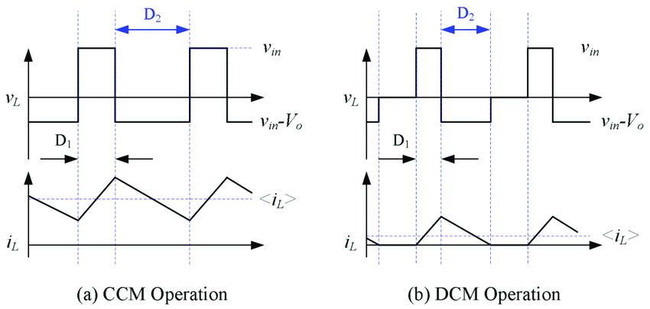.

(b)

(a)

Figure 2.15: Boost converter waveforms at (a) CCM and (b) DCM

In this project, the voltage output of the solar panel is lower than the charging voltage of the battery. So, a boost converter is implemented between the solar panel and battery to set up the out voltage of the solar panel to 12V for charging the battery.

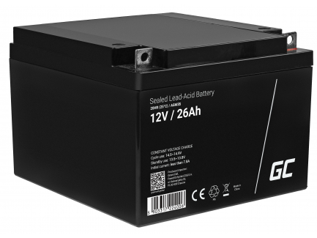**2.12 BATTERY**

The battery used in this project is a rechargeable sealed lead acid battery rating 12V-26Ah (demonstrated in the Figure 2.16). This type of battery is excellent for rechargeable purpose. A rechargeable battery or storage battery is a group of one or more electrochemical cells. They are known as secondary cells because their electrochemical reactions are electrically reversible. Rechargeable batteries come in many different shapes and sizes, ranging anything from a button cell to megawatt systems connected to stabilize an electrical distribution 22 network. Several different combinations of chemicals are commonly used, some of them are lead– acid, nickel cadmium (Ni-Cd), nickel metal hydride (NiMH), lithium ion (Li-ion), and lithium ion polymer (Li-ion polymer). Rechargeable sealed lead acid battery batteries have lower cost of use and environmental impact than disposable batteries. Rechargeable sealed lead acid batteries have lower cost of operation and longer life as compared to other batteries.

Figure 2.16: Lead Acid Battery

**2.13 TRANSFORMER**

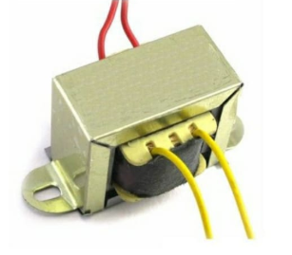One of the most important components of our inverter circuit is the transformer. It offers the much-required capability of changing the current and voltage levels simply. The main function of the transformer is that to increase (step-up) or decrease (step-down) AC voltages without changing the frequency. Here we use single phase, 8/240 V step up transformer as shown in Figure 2.17.

Figure 2.17: 8/240V- Single Phase Transformer

**2.14 ARDUINO**

Arduino is an open-source electronics platform based on easy-to-use hardware and software. It can read inputs like light on a sensor, a fingerprint, a button, Twitter message, etc… and can turn this into an output like activating a motor, turning LED lights on, or publishing something online. Nowadays Arduino serves as a brain to many projects ranging from simple to highly complex scientific instruments. The Arduino software is very popular because of its user-friendly and easy approach for beginners, and it is flexible enough for advanced users. It runs on Mac, Windows, and Linux. Teachers and students use it to build low-cost scientific interactive prototypes of instruments. There are many other microcontrollers and microcontroller boards available for physical computing. The most common controller boards are Arduino and Raspberry Pi. They differ based on the control units present in them. Arduino belongs to ATmega while Raspberry Pi comes from the ARM family. Arduino has been selected for our project because of the following advantages.

Advantages of Arduino over Raspberry Pi are:

* Inexpensive.
* Provide a simple and clear programming environment.
* Simple to write codes and execution.
* It consumes low power.
* Real-time applications for both hardware, software, and IDE.

**2.15 RASPBERRY Pi**

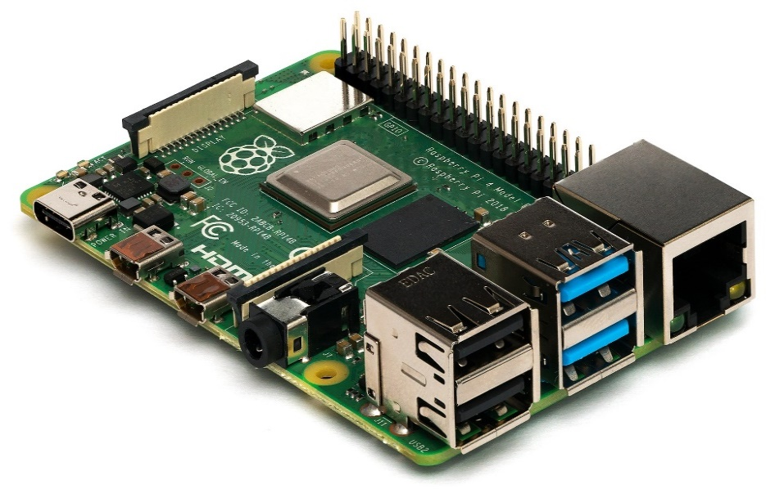Raspberry Pi (Figure 2.18)  is a series of small [single-board computers](https://en.wikipedia.org/wiki/Single-board_computer) (SBCs) developed in the [United Kingdom](https://en.wikipedia.org/wiki/United_Kingdom) by the [Raspberry Pi Foundation](https://en.wikipedia.org/wiki/Raspberry_Pi_Foundation) in association with [Broadcom](https://en.wikipedia.org/wiki/Broadcom_Inc.). The Raspberry Pi project originally leaned towards the promotion of teaching basic [computer science](https://en.wikipedia.org/wiki/Computer_science) in schools and in [developing countries](https://en.wikipedia.org/wiki/Developing_countries).The original model became more popular than anticipated, selling outside its [target market](https://en.wikipedia.org/wiki/Target_market) for uses such as [robotics](https://en.wikipedia.org/wiki/Robotics). It is widely used in many areas, such as for weather monitoring, because of its low cost, modularity, and open design. It is typically used by computer and electronic hobbyists, due to its adoption of HDMI and USB devices.

Figure 2.18: Raspberry Pi

An SD card inserted into the slot on the board acts as the hard drive for the Raspberry Pi. It is powered by USB and the video output can be hooked up to a traditional RCA TV set, a more modern monitor, or even a TV using the HDMI port. It does not replace your computer, since the Ethernet is only a 10/100 and the processor is not as fast, it is time consuming to download and install software and is unable to do any complex multitasking.

**CHAPTER-3**

**MPPT BASED SOLAR INVERTER**

**3.1 CHAPTER OVERVIEW**

This chapter deals with principle, components, applications as well as advantages and disadvantages of Solar Inverter.

**3.2 BASIC PRINCIPLE OF SOLAR INVERTER**

Solar energy is changed to electrical energy with the help of photovoltaic cells. This energy is stored in batteries during daytime for the operation purpose whenever needed. The proposed system is designed to utilize solar energy for home loads using an inverter. A solar inverter, or PV inverter, converts the variable direct current (DC) output of a photovoltaic (PV) solar panel into a utility frequency alternating current (AC) that can be fed into a commercial electrical grid or used by a local, off-grid electrical network.

In this proposed system, the solar energy is stored in the battery from PV cells. This energy of the battery is altered to AC supply of 50Hz frequency using SPWM inverter which is controlled by MOSFET gate driver circuit by following the commands from the Arduino module and then step-up the voltage to 230V by a transformer and is then fed to the load.

**3.3 BLOCK DIAGRAM**

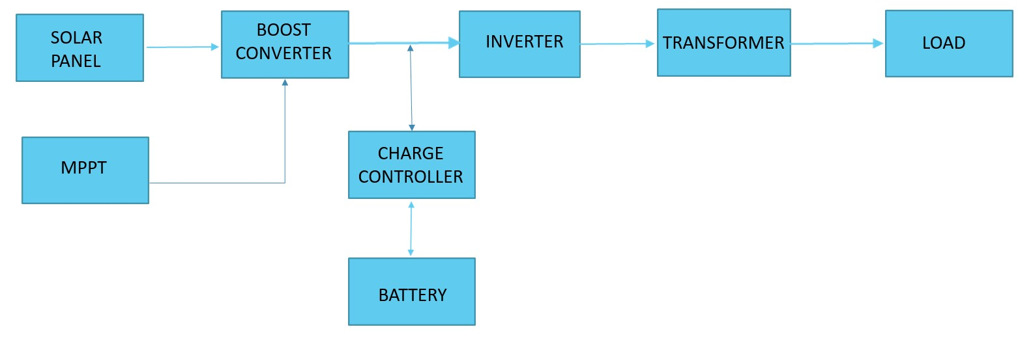

Figure 3.1: Block Diagram of Solar Inverter

The solar panel traps energy from sunlight and provides energy in the form of DC power and the boost converter with the help of MPPT provides stable 12V DC as output. Excess energy is stored in the battery with help of a charge controller, usually, modern batteries are factory fitted with these controllers. The DC power from either the battery or the panel is fed to the inverter and is converted into AC voltage. It is then stepped up to the required voltage level depending on the load. The block diagram of this project is illustrated in the Figure 3.1.

**3.3.1 PV PANEL**

Photovoltaic modules use light energy (absorb photons) from the Sun to generate electricity through the photovoltaic effect. Solar cells are electrically connected and fabricated as a module with a sheet of glass on top to allow light to pass and protect the semiconductor from the weather. The output from PV panel is fed to solar charge controller.

**3.3.2 BOOST CONVERTER**

A boost converter is a DC-DC power converter that steps up voltage from its input to its output. The boost converter is a medium of power transmission to perform energy absorption and injection from solar panel to battery.

**3.3.3 MPPT**

It adjusts the input voltage and harvest maximum power from solar panel.

**3.3.4 CHARGE CONTROLLER**

It is essential to regulate the voltage output from the solar panel before it is supplied to the battery. A DC buck converter is used as charge controller, which steps down the voltage and used to charge lead acid battery.

**3.3.5 LEAD ACID BATTERY**

Lead acid battery is used to store the electrical energy from solar panel. The battery is charged via charge controller and is used power the inverter.

**3.3.6 INVERTER**

The inverter converts the DC power from the battery or panel to AC power.

**3.3.7 TRANSFORMER**

The AC power from the inverter is stepped up to 240V in order to meet the load demand.

**3.3.8 LOAD**

AC loads are devices which receives alternating-current (AC) electrical power from a source in an electrical system. Some common examples of AC loads are microwave oven, hair dryer, common lighting, etc.

**3.4 APPLICATIONS**

1. **DC POWER SOURCE UTILIZATION**

An inverter converts the DC electricity from sources such as batteries, solar panels, or fuel cells to AC electricity. The electricity can be at any required voltage; in particular it can operate AC equipment designed for mains operation, or rectified to produce DC at any desired voltage.

1. **UNINTERRUPTIBLE POWER SUPPLY**

An uninterruptible power supply (UPS) uses batteries and an inverter to supply AC power when main power is not available. When main power is restored, a rectifier supplies DC power to recharge the batteries.

1. **HVDC POWER TRANSMISSION**

With HVDC power transmission, AC power is rectified and high voltage DC power is transmitted to another location. At the receiving location, an inverter in a static inverter plant converts the power back to AC.

1. **THE GENERAL CASE**

A transformer allows AC power to be converted to any desired voltage, but at the same frequency. Inverters, plus rectifiers for DC, can be designed to convert from any voltage, AC or DC, to any other voltage, also AC or DC, at any desired frequency. The output power can never exceed the input power, but efficiencies can be high, with a small proportion of the power dissipated as waste heat.

1. **AT REMOTE LOCATIONS**

AC power can be generated at places where the grid supply is unavailable.

**3.5 ADVANTAGES**

1. Solar energy decreases the greenhouse effect as well as abnormal weather change.
2. It can serve as an emergency power source.
3. It is portable.
4. Parts of solar inverter is readily available, and can be replaced when a component gets faulty.
5. By using solar products, we can save money by reducing electricity bills
6. The solar inverter is used to change DC to AC and this is a reliable source of energy.
7. These inverters empower small businesses by reducing their energy needs and requirements.
8. These are multifunctional devices as they preprogramed to alter DC to AC which assists large energy consumers.
9. Easy to set up and more reasonable compared with generators.
10. Maintenance is easy as they work well even with usual maintenance.

**3.6 DISADVANTAGES**

1. Requires high initial cost for installation.
2. Sunlight is necessary to generate sufficient electricity.
3. It requires a huge space for installation.
4. It requires a battery to work at night time to provide proper electricity to the home, commercial, etc.

**CHAPTER 4**

**SELECTION AND DESIGN OF COMPONENTS**

**4.1 CHAPTER OVERVIEW**

This chapter sheds light on how the project is advanced from components selection, software selection, PWM programming, circuit construction and to simulation result. It also summarises the cost expected for the hardware implementation.

**4.2 COMPONENTS SELECTION AND DESIGN**

Basic components like Solar panel, Battery, Boost Converter, and inverter which consists of inductor, capacitor, IGBT switch, filter capacitor etc.

**4.2.1 SOLAR PANEL**

**1. Determine power consumption demands**

The first step in designing a solar PV system is to find out the total power and energy consumption of all loads that need to be supplied by the solar PV system as follows:

1.1 Calculate total Watt-hours per day for each appliance used.

Add the Watt-hours needed for all appliances together to get the total Watt-hours per day which must be delivered to the appliances.

1.2 Calculate total Watt-hours per day needed from the PV modules.

Multiply the total appliances Watt-hours per day times 1.3 (the energy lost in the system) to get the total Watt-hours per day which must be provided by the panels.

**2. Size the PV modules**

Different size of PV modules will produce different amount of power. To find out the sizing of PV module, the total peak watt produced needs. The peak watt (Wp) produced depends on size of the PV module and climate of site location. We have to consider "panel generation factor" which is different in each site location. For Thailand, the panel generation factor is 3.43. For India, the panel generation factor is 5.

To determine the sizing of PV modules, calculate as follows:

2.1 Calculate the total Watt-peak rating needed for PV modules

Divide the total Watt-hours per day needed from the PV modules (from item 1.2) by 3.43 to get the total Watt-peak rating needed for the PV panels needed to operate the appliances.

2.2 Calculate the number of PV panels for the system

Divide the answer obtained in item 2.1 by the rated output Watt-peak of the PV modules available to you. Increase any fractional part of result to the next highest full number and that will be the number of PV modules required.

Result of the calculation is the minimum number of PV panels. If more PV modules are installed, the system will perform better and battery life will be improved. If fewer PV modules are used, the system may not work at all during cloudy periods and battery life will be shortened.

**Solar Panel Designing**

* Determine power consumption demands

Total power use = 160W x 4 hours per day

= 640 Wh/day

Total PV panels energy needed = 640 x 1.3

= 832 Wh/day

* Size the PV panel

Total Wp of PV panel capacity needed $=\frac{Total PV panel energy needed}{Average annual solar irradiation in kerala}$

$=$ $\frac{832}{5}$

$=$ 166.4 Wp

Selected Panel Wp = 93.84.

* Number of PV panels needed $=\frac{166.4}{93.84}$

$=1.77$

So, this system should be powered by at least **2** number of 93.84 Wp PV module.

**4.2.2 BOOST CONVERTER**

Input current = 19.89A

Current ripple, ΔI = 0.99A = 5%

Voltage ripple, ΔV = 0.25V = 1%

Output current = 15 A

Rated power = 180W

fsw = 40KHz

Voltage Output = 12 V

Voltage input = 9.5 V

Inductance, L **= $\frac{Vip (Vop – Vip)}{Vop* fsw*ΔI}=\frac{9.5*\left(12 - 9.5\right)*100}{12*4000*5}$ $=.98mH$**

Capacitance, C **= $\frac{Iop ( Vop –Vip)}{Vop*ΔV*fsw}=\frac{15 *(12 -9.5)*100}{12*1*40000}$ $=7.8mF$**

**4.2.3 BATTERY SIZING**

Total appliances use = 160 x 1 hours

Nominal battery voltage = 12V

Days of autonomy = 1 day

Efficiency × Depth of discharge x nominal battery voltage

Total watt hours per day used × Days of Autonomy

$Battery capacity =$

160 × 1

$=$

0.85 × 0.6 × 12

Total Ah required = 26.14 Ah

A lead acid battery of 12 V, 26 Ah is selected.

**4.2.4 LC FILTER**

R = 230Ω

Maximum inductance of load LL =1.1H

Frequency = 50Hz

Capacitance, C $=\frac{1}{2*ω*√(R^{2}+{(2*ω*L_{L})}^{2}}=2.19µF$

$Inductance, L=\frac{1}{4*9.85*f^{2}*C}=4.62H$

**4.2.5 INVERTER**

**DESIGN ANALYSIS OF THE POWER CIRCUIT**

Current Rating = $\frac{250}{8}=31.25 A$

Having 2 identical MOSFETS, the required current rating for each of the MOSFETS, for each side of transformer can be determined.

Required current rating for each MOSFETS = $\frac{31.25}{2}=15.63 A$

To prevent the MOSFETS from burning out due to excessive current, it is advised to use a MOSFETS of three times the required MOSFETS current rating.

Therefore, 15.63* 3= 46.89 A

Hence, 4 MOSFETS of 60 A were used, with 2 on each side of the transformer for protection of the MOSFETS.

**4.2.6 BOOTSTRAP CIRCUIT**

Selecting DBOOT, and CBOOT

**TABLE I**

**PARAMETERS OF BOOTSTRAP CIRCUIT**

|  |  |  |
| --- | --- | --- |
| **PARAMETER** | **VALUE** | **COMMENTS** |
| 𝑉𝑠𝑠 | 16 V | Supply voltage to MGD |
| 𝑉𝐹_𝐵𝑂𝑂𝑇 | 0.7 V | Forward voltage drop of bootstrap diode. |
| ∆𝑉𝐵𝑂𝑂𝑇 | 0.9V | Acceptable voltage drop across bootstrap capacitor. |

So CBOOT can be calculated as,

CBOOT

QTOTAL = Qgate + ( ILKCAP + ILKGS+ IQBS + ILK + ILKDIODE ) * TON + QLS

Qgate =total gate charge of MOSFET

ILKCAP = Bootstrap capacitor leakage current.

ILKGS =Switch gate source leakage current.

IQBS = Bootstrap circuit Quiescent current.

ILK = Bootstrap circuit leakage current.

ILKDIODE = Bootstrap diode leakage current.

QLS = Charge required by the internal level shifter, which is set to 3nC for all HV gate drivers.

For MOSFET at this voltage range, have a 𝑄𝑔𝑎𝑡𝑒 of 16nC.

Taking worst case:

Qgate =16nC

The actual value of Qgate should be lower than the above value selected for efficient operation.

ILKCAP = 100 μA

ILKGS = 100nA

IQBS = 230 μA

ILK = 50 μA

ILKDIODE = 0.5mA

QLS = 3 nC

TON = 10 mS

By Solving,

QTOTAL =16×10−9+(100×10−6+200×10−9+230×10−6+50×10−6+0.5×10−3)×10×10−3 +3×10-9

QTOTAL = 8.821 μC

$C_{BOOT}≥\frac{8.821μC}{.9}≥9.801 μF$

Actual CBOOT selected is 22μF and DBOOT RU3AM.

**4.2.7 DIODE**

Since the current in the inductor cannot change instantaneously, a path must exist for the inductor current when the switch is off (open). This path is provided by the freewheeling diode (or catch diode). The purpose of this diode is not to rectify, but to direct current flow in the circuit and to ensure that there is always a path for the current to flow into the inductor. It is also necessary that this diode should be able to turn off relatively fast. Thus the diode enables the converter to convert stored energy in the inductor to the load.

**4.2.8 ARDUINO UNO**

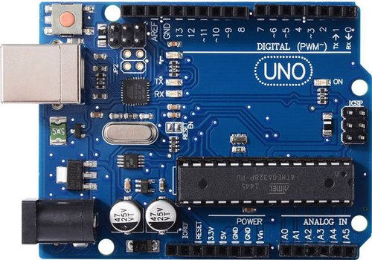The Arduino Uno (shown in Figure 4.1) is a microcontroller board based on the ATmega328 (datasheet). It has 14 digital input/output pins (of which 6 can be used as PWM outputs), 6 analog inputs, a 16 MHz ceramic resonator, a USB connection, a power jack, an ICSP header, and a reset button. It contains everything needed to support the microcontroller; simply connect it to a computer with a USB cable or power it with an AC-to-DC adapter or battery to get started. The Uno differs from all preceding boards in that it does not use the FTDI USB to-serial driver chip. Instead, it features the Atmega16U2 (Atmega8U2 up to version R2) programmed as USB-to-serial converter.

Figure 4.1: Arduino Uno

Each of the 14 digital pins on the Uno can be used as an input/output, using pin Mode, digital Write, and digital Read functions. They operate at 5 volts and can provide or receive a maximum of 40 mA and has an internal pull-up resistor (disconnected by default) of 20-50 kΩ’s.

**TABLE II**

**TECHNICAL SPECIFICATIONS OF ARDUINO UNO**

|  |  |  |
| --- | --- | --- |
| **Sl. No.** | **Features** | **Specifications** |
| 1 | Microcontroller | ATmega328 |
| 2 | Operating Voltage | 5V |
| 3 | Input Voltage (Recommended) | 7-12V |
| 4 | Input Voltage (Limits) | 6-20V |
| 5 | Digital I/O Pins | 14 (6 Provide PWM Output) |
| 6 | Analog Input Pins | 6 |
| 7 | DC Current I/O Pin | 40 mA |
| 8 | DC Current for 3.3V Pin | 50 mA |
| 9 | Flash Memory | 32 kB (ATmega328) |
| 10 | SRAM | 2 kB (ATmega328) |
| 11 | EEPROM | 1 kB (ATmega328) |
| 12 | Clock Speed | 16 MHz |

**4.2.9 ARDUINO NANO**

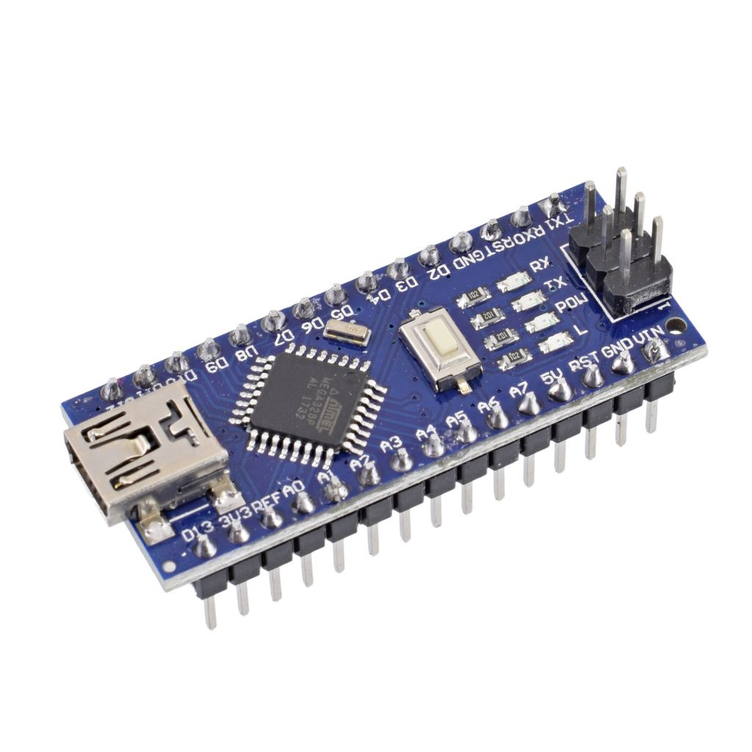The Arduino Nano (shown in Figure 4.2) is a small, complete, and breadboard-friendly board based on the [ATmega328P](https://en.wikipedia.org/wiki/ATmega328) released in 2008. It offers the same connectivity and specs of the [Arduino Uno](https://en.wikipedia.org/wiki/Arduino_Uno) board in a smaller form factor.

The Arduino Nano is equipped with 30 male [I/O](https://en.wikipedia.org/wiki/I/O) headers, in a [dip-30](https://en.wikipedia.org/wiki/Dual_in-line_package) like configuration, which can be programmed using the [Arduino](https://en.wikipedia.org/wiki/Arduino) Software [integrated development environment](https://en.wikipedia.org/wiki/Integrated_development_environment) (IDE), which is common to all Arduino boards and running both online and offline. The board can be powered through a [type-b micro-USB cable](https://en.wikipedia.org/wiki/USB_cable), or through a 9V battery. In 2019, Arduino released the Arduino Nano Every, a pin-equivalent evolution of the Nano. It features a more powerful [ATmega4809](https://en.wikipedia.org/w/index.php?title=ATmega4809&action=edit&redlink=1) processor, and twice the RAM.

Figure 4.2: Arduino Nano

**TABLE III**

**TECHNICAL SPECIFICATIONS OF ARDUINO NANO**

|  |  |  |
| --- | --- | --- |
| **Sl. No.** | **Features** | **Specifications** |
| 1 | Microcontroller | ATmega328 |
| 2 | Architecture | AVR |
| 3 | Operating Voltage | 5 V |
| 4 | Flash Memory | 32 KB of which 2 KB used by bootloader |
| 5 | SRAM | 2 KB |
| 6 | Clock Speed | 16 MHz |
| 7 | Analog I/O Pins | 8 |
| 8 | EEPROM | 1 KB |
| 9 | DC Current per I/O Pins | 40 mA |
| 10 | Input Voltage | 7-12 V |
| 11 | Digital I/O Pins | 22 |
| 12 | PWM Output | 6 |
| 13 | Power Consumption | 19 mA |
| 14 | PCB Size | 18 x 45 mm |
| 15 | Weight | 7 g |
| 16 | Product Code | A000005 |

**4.3 SOFTWARE SELECTION**

C language is chosen to write the PWM program for the Arduino UNO R3. The C programming is written in Arduino Integrated Development Environment (IDE) software. The circuit for the Solar Module, Boost Converter with MPPT Topology, SPWM Inverter with load is designed and simulated in MATLAB environment.

**4.3.1 MATLAB**

MATLAB is a high-performance language for technical computing. It integrates computation, visualization, and programming environment. Furthermore, MATLAB is a modern programming language environment: it has sophisticated data structures, contains built-in editing and debugging tools, and supports object-oriented programming. These factors make MATLAB an excellent tool for teaching and research. MATLAB has many advantages compared to conventional computer languages (e.g., C, FORTRAN) for solving technical problems. MATLAB is an interactive system whose basic data element is an array that does not require dimensioning. The software package has been commercially available since 1984 and is now considered as a standard tool at most universities and industries worldwide. It has powerful built-in routines that enable a very wide variety of computations. It also has easy to use graphics commands that make the visualization of results immediately available. Specific applications are collected in packages referred to as toolbox. There are toolboxes for signal processing, symbolic computation, control theory, simulation, optimization, and several other fields of applied science and engineering.

**4.3.2 PROTEUS**

Proteus is software for microprocessor and microcontroller simulation, schematic capture, and printed circuit board (PCB) design. It is developed by Lab center Electronics. Figure 4.3 shows Proteus window.

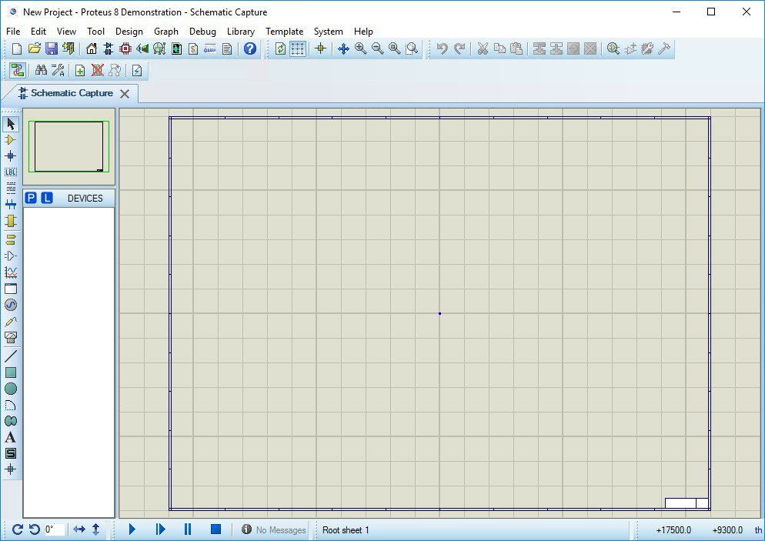

Figure 4.3: Proteus Window

Proteus consists of a single application with many modules such as ISIS Schematic Capture to design the buck converter circuit and VSM mode to simulate the buck converter circuit.

**4.3.3 ARDUINO IDE**

The Arduino Integrated Development Environment - or Arduino Software (IDE) - contains a text editor for writing code, a message area, a text console, a toolbar with buttons for common functions and a series of menus. It connects to the Arduino and Genuino hardware to upload programs and communicate with them.

**4.4 COST ESTIMATION**

Exploitation of solar energy especially by the installation of photovoltaic systems has escalated throughout the past years due to many reasons such as: increased rate of the price of electricity, diesel oil, the improvements in techniques used for installing solar systems, increase in efficiency of solar systems, environmental concern etc. Considering the substantial initial capital required for installation, PV power plant is more expensive than other resources. Several governments are promoting the use of solar modules by providing subsidies or feed-in tariffs, expecting a further development of the technology and with an agenda to make it more popular. By increasing the efficiency of PV plants, the net power generated blooms which is a key aspect, as it will increase the incomes, and thus reducing the statutory cost of power generation.

With rapid progression in the usage of solar energy power derived devices, there was a dramatic drop in the prices of solar module accessories. It is reported that the prices are declining at a rate of 4% per annum over the last 15 years. Although installing a PV system costs a considerable amount of money, these systems can be of economic benefit in the long run. This is due to the fact that a big amount of money is paid once to purchase the system after which the annual costs are limited to maintenance, and upgrading the power delivery system. This annual cost inquired are little as compared to the cost for running a diesel engine (maintenance, fuel etc...), and they range between 0.02 and 0.1 cents/kWh.

The complete cost estimated for “Intelligent Solar Inverter” in accordance with the proposed design parameters is provided in the Table IV.

**TABLE IV**

**COST ESTIMATION**

|  |  |  |
| --- | --- | --- |
| **Sl. No** | **COMPONENTS** | **COST(in Rupees)** |
|  | Lead acid battery | 800 |
|  | Voltage Regulator | 45 |
|  | MOSFET Gate driver | 1100 |
|  | MOSFET-P55nf06 | 140 |
|  | Transformer | 145 |
|  | Surface Mount Device | 40 |
|  | Arduino Nano | 375 |
|  | Arduino UNO | 585 |
|  | Resistors | 150 |
|  | Capacitors | 250 |
|  | Diode | 3 |
|  | Boost Converter | 155 |
|  | PV Panel | 3000 |
|  | Miscellaneous | 300 |

The total estimated cost was Rs.7088.The hardware implementation cost was nearly Rs.3350 as PV panel and boost converter were excluded.

**CHAPTER 5**

**SIMULATION STUDIES AND RESULTS**

**5.1 CHAPTER OVERVIEW**

This chapter showcases the various PROTEUS and MATLAB simulations, observations and results.

**5.2 SIMULATION OF GATE PULSES**

The switching pulses for the gate of the transistor pairs (S1-S4 & S2-S3) should be such that during the time interval in which a pair is being operated the other set should be in the off state. To produce gate pulse (sine pulse width modulated signals) of frequency 50Hz switching at about 40 kHz and also the pulses are present only in the interval of 00 – 1800 (remains off for 1800 – 3600), a sine wave is compared with triangular wave and the output is high only when the amplitude of the sine wave supersedes that of the triangular wave. The next set of pulses operates during the time in which the former pulse is in the off state.

Using a similar logic, required gate pulses for the transistors of the H-bridge can be obtained from an Arduino module. The output of Gate Pulse Simulation is shown in the Figure 5.1.

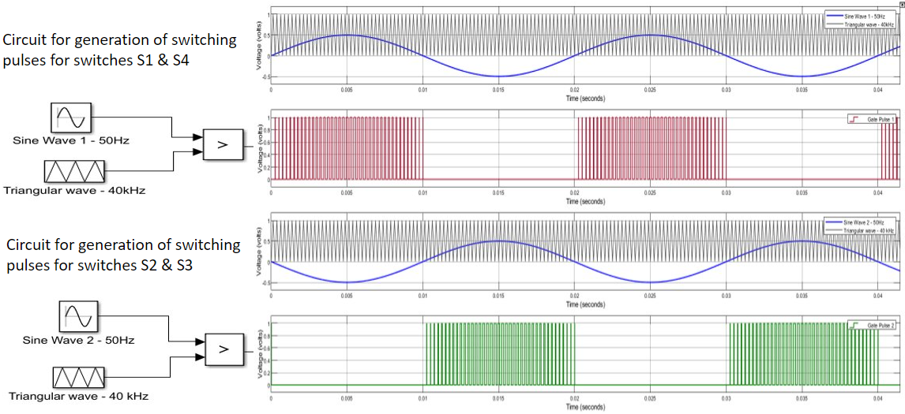

Figure 5.1: SPWM Gate Pulses

**5.3 SIMULATION OF GATE DRIVER CIRCUIT**

Square pulses are provided to MOSFET Gate Driver ICs to check if the circuit works properly. In an actual hardware implementation, SPWM signals of 5 Volts are given at the input terminals of the ICs and the MOSFET gate driver circuit boosts this into 12 V AC peak to peak and is then fed to the transformer. The gate driver circuit and the output waveforms are shown in the Figures 5.2 and 5.3 respectively.

Figure 5.2: MOSFET Gate Driver Circuitry

Figure 5.3: MOSFET Gate Driver Circuitry with amplified SPWM (12Vpp)

**5.4 SIMULATION OF PV PANELS**

PV module represents the fundamental power conversion unit of a PV generator system. The output characteristic of PV module depends on the solar insolation and the cell temperature. In PV modelling, the solar energy is directly converted into electrical energy by the photovoltaic cell. The modelling of the photovoltaic system is done by connecting two PV strings in parallel as shown in Figure 5.4.

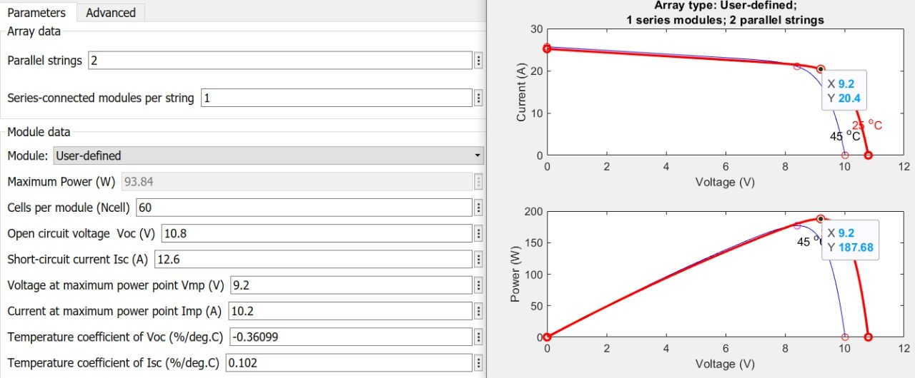

Figure 5.4: PV Panel Characteristics

**5.4 SIMULATION OF INVERTER CIRCUIT**

The inverter circuit with h-bridge was studied by simulation using the configuration shown in Figure. There are four MOSFET forming the H-bridge which are switched in accordance with the gate pulses. The battery provides 12V DC to the inverter circuit. The simulations are made to illustrate the response of the whole system. From the graph, it is very clear that the inverter operates satisfactorily under the designed parameters.

The simulation of solar inverter with battery as the power source is depicted in the Figure 5.5 and the Output Waveforms of Gate Pulses, Current and Voltage are shown in the Figure 5.6.

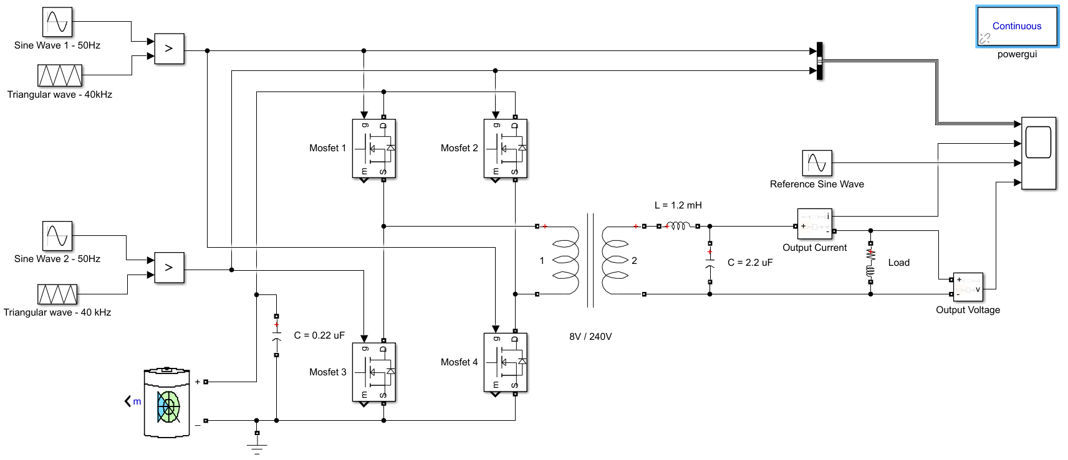

Figure 5.5: MATLAB Simulation of Inverter Circuit

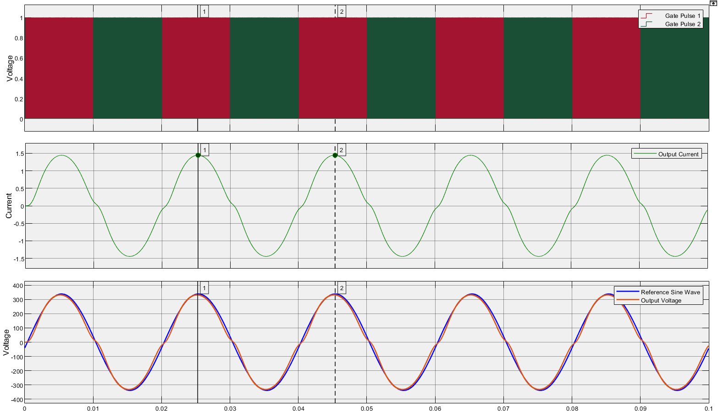

Figure 5.6: MATLAB Simulation Output

**5.5 SIMULATION OF THE PROPOSED SYSTEM**

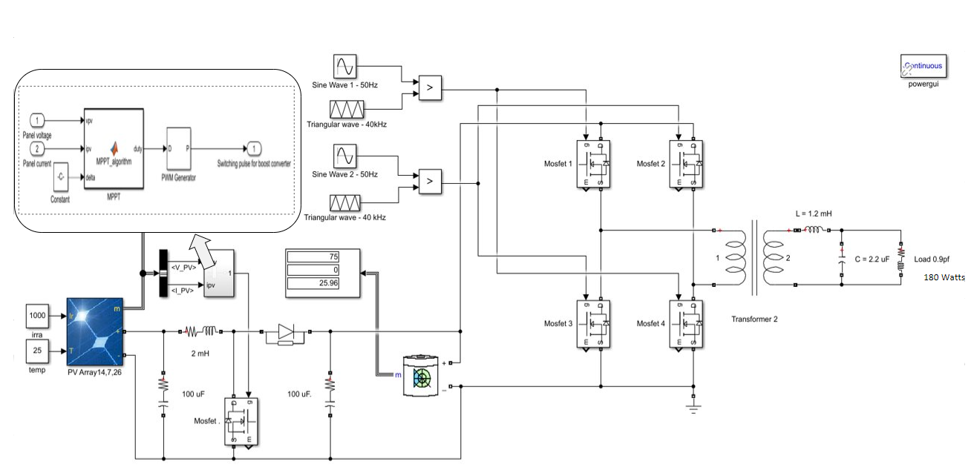

Figure 5.7: Inverter circuit with integrated MPPT

On simulation of the entire proposed project (shown in Figure 5.7), the MPPT algorithm made sure that the power output remained at maximum efficiency. The MPPT control signals are provided to the gate terminals of the boost converter which maintained a constant voltage of 12V. The output waveform from the boost converter is shown in Figure 5.8 revealed the same.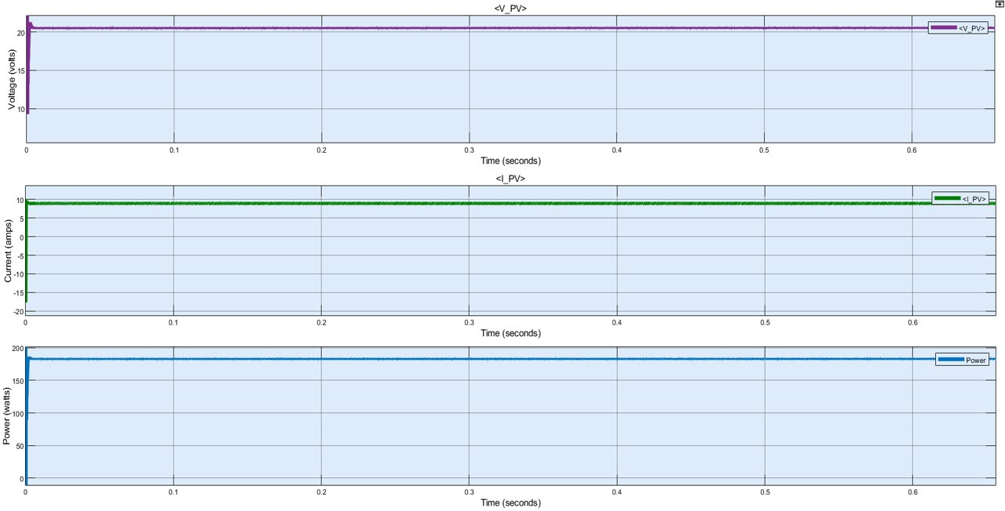

Figure 5.8: Panel Output with MPPT incorporation

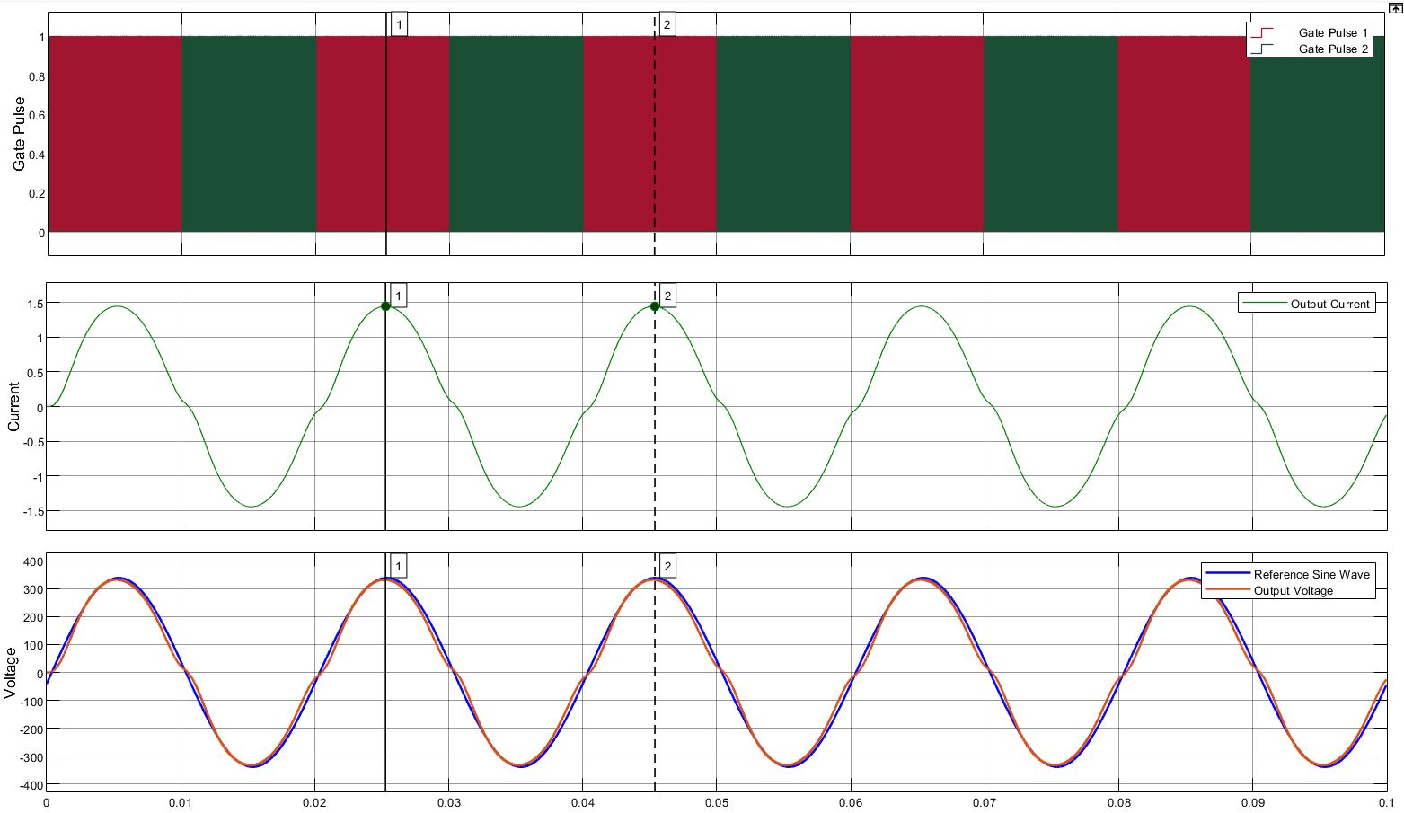

Figure 5.9: Inverter Output

**5.6 SIMULATION ANALYSIS**

As per the designed simulation parameter values, the satisfactory output was observed and are as follows:

Output voltage = 240 V

Output current = 1.05 A

**CHAPTER 6**

**HARDWARE IMPLEMENTATION AND OUTPUTS**

**6.1 CHAPTER OVERVIEW**

This chapter comprises of the components that were implemented for the successful completion of the hardware part of the inverter module and the obtained outputs.

**6.2 BATTERY**

Batteries are used to provide uninterrupted power supply to the load under varying conditions. A 12V lead acid battery is used for powering the inverter. It is a 7 Ah C20 rated battery and is sufficient enough to carry the designed load for 1 hr.

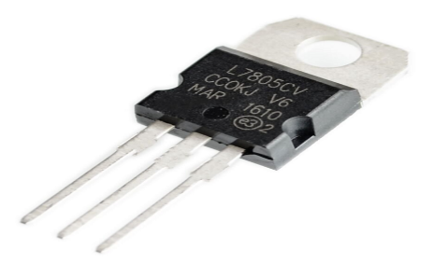**6.3 VOLTAGE REGULATOR**

IC 7805 (Figure 6.1) is a 5V Voltage Regulator that restricts the output voltage to 5V output for various ranges of input voltage. It acts as an excellent component against input voltage fluctuations for circuits, and adds an additional safety to the circuitry. Here, the voltage regulator converts 12V to stable 5V DC output for the various components.

Figure. 6.1: L7805 Voltage Regulator

**6.4 GATE PULSE GENERATION**

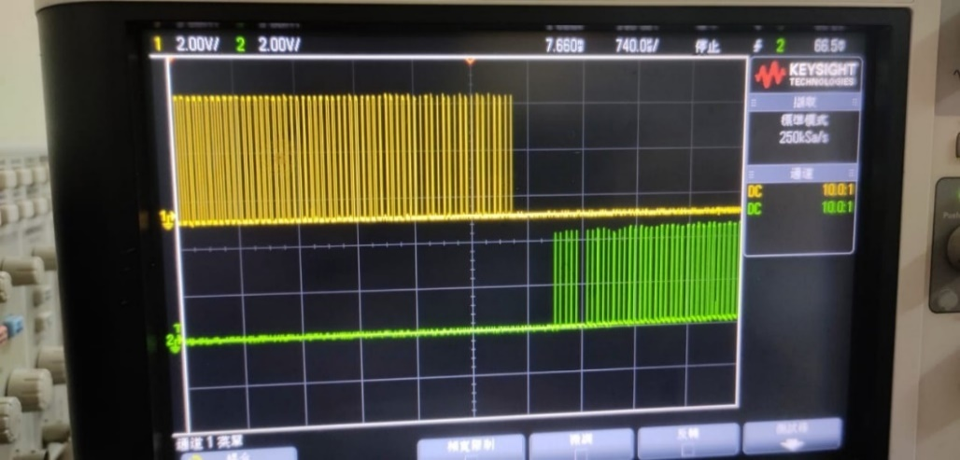Gate Pulses are generated using Arduino, which is then fed to MOSFET (p55nf06) with the help of MOSFET Gate Driver (IR2110). A gate driver is used when a pulse-width-modulation (PWM) controller cannot provide the output current required to drive the gate capacitance of the associated MOSFET. Gate drivers may be implemented as dedicated ICs, discrete transistors, or transformers. They can also be integrated within a controller IC. Output from Arduino is shown in figure 6.2.

Figure. 6.2: Arduino Output (SPWM Gate Pulses)

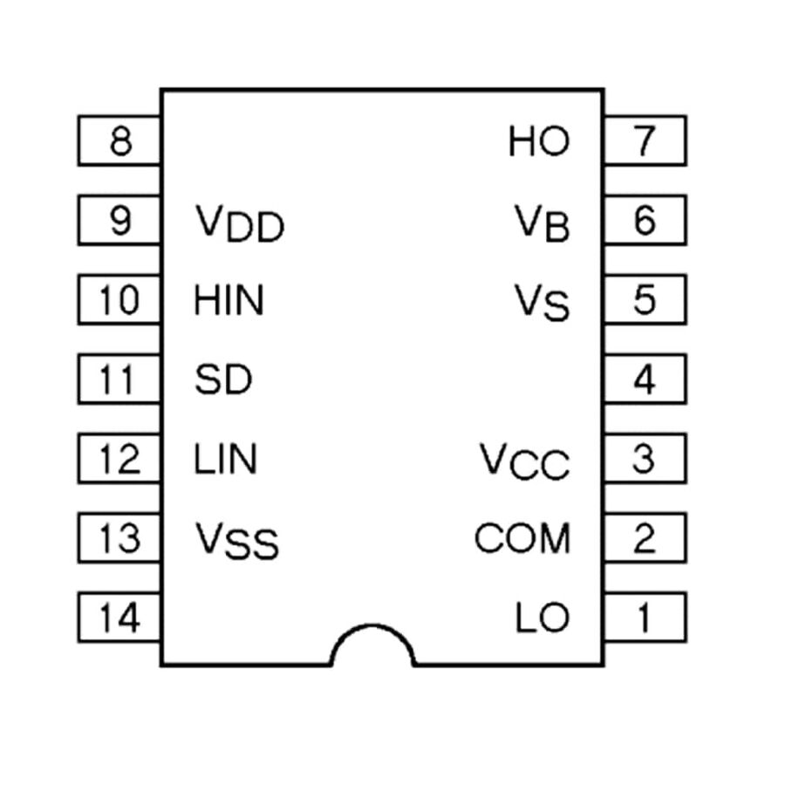**6.5 GATE DRIVER**

The IR2110 (Figure 6.3) is a high voltage, high speed power MOSFET and IGBT driver with independent high and low side referenced output channels. Operating supply voltage range for IR2110 is 10 to 20 volt and output current is 2.5A. IR2110 comes in 14 pin through-hole PDIP package and the 16-pin surface mount SOIC package.

Figure 6.3: IR2110 Gate Driver

**6.6 SURFACE MOUNT DEVICE**

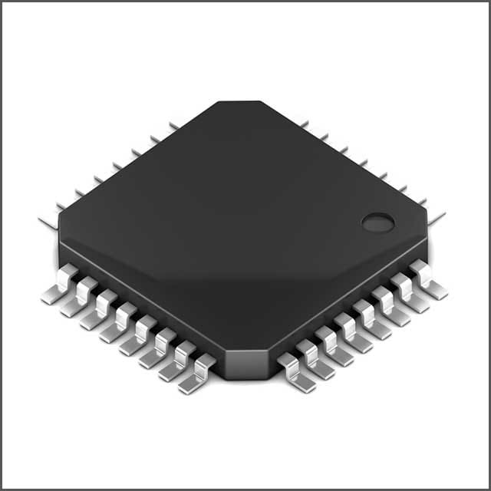A surface-mount device (SMD) is an electronic device for which the components are mounted or placed directly onto the surface of the PCB. Surface-mount technology, or SMT, is the name of the method used for producing an SMD. In the industry it has largely replaced the through-hole technology construction method of fitting components with wire leads into holes in the circuit board. A typical SMD is shown in figure 6.4.

Figure 6.4: Surface Mount Device

Both technologies can be used on the same board for components not suited to surface mounting such as large transformers and heat-sinked power semiconductors. An SMT component is usually smaller than its through-hole counterpart because it has either smaller leads or no leads at all. It may have short pins or leads of various styles, flat contacts, a matrix of solder balls (BGAs), or terminations on the body of the component.

**6.7 PCB DESIGNING**

**6.7.1 INTRODUCTION**

A PCB is used to mechanically support and electrically connects electronic components using conductive pathways, tracks or etched from copper sheets. It is also referred to as PWB. A PCB populated with electronic components is PCA, also known as a PCBA. PCB is inexpensive, and can be highly reliable. They require much more layout effort and higher initial cost than either wire-wrapped or point-to-point constructed circuits, but are much cheaper and faster for high-volume production. One of the most discouraging things about making a hardware project is building PCB. Due to the improvements in printing technologies, it is now relatively easy to make inexpensive high-quality PCBs at home. PCB stands for Printed Circuit Board. It is of two types:

General purpose - It is already drilled and etched.

Special purpose - It requires step by step process of making layout then etching and then drilling.

**6.7.2 PCB CONSTRUCTION**

The different processes that take place in the fabrication of a PCB are as follows: -

1. Layout designing

2. Transfer of pattern on copper board.

3. Drying

4. Etching

5. Tinning

6. Drilling

7. Soldering

8. Surface cleaning

9. Final inspection of PCB

**6.7.3 LAYOUT DESIGNING**

First of all, layout design of the circuit switch, to be traced on the PCB, is prepared. The layout of a PCB has to incorporate all the information on the board; one can go to the art of work preparation. The detailed circuit diagram is very important for the layout designer but one must also have familiar with the design concept & with the philosophy behind the equipment. In this process the layout designer, traces the circuit on a graph paper. By this process he/she marks where the holes should be. Thus, the circuit, which is to be traced on the PB, is firstly traced on the graph paper or its layout is designed. In layout designing the distance between the copper tracks & length, size etc. of components are also taken into consideration.

**6.7.4 TRANSFER OF PATTERN**

After designing the art work on the graph paper, we transferred it onto the trace paper. The conductor pattern is then transferred to the copper clad lamination with the help of carbon paper. By this, the pattern gets transferred on the copper clad lamination.

**6.7.5 ETCHING**

Etching is done to remove all the unwanted copper which is present on the portion other than the pattern on the PCB. For this the PCB is kept dipped in the solution (FeCl2) and two or three drops of HCL. The chemicals react with copper & dissolve it. After some hours of time, we get the PCB left with only copper tracks on it.

**6.7.6 TINNING**

The board is tinned using a soldering iron and a small piece of tinned solder wick. Tinning isn't absolutely necessary but it improves the appearance of the board and prevents the copper from oxidizing before it's time to solder the parts to the board.

**6.7.7 DRILLING**

Drilling of component mounting holes into PCB is the most important mechanical matching operation in PCB production process. Holes are made by drilling where ever a superior hole finish in is required. Therefore, drilling is applied by all the professional grade PCB manufacturers & generally in all smaller PCB production plants & laboratories.

**6.7.8 SOLDERING**

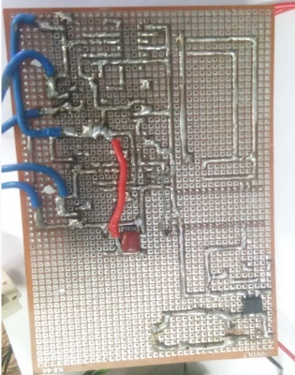Soldering is the process of joining two metallic conductors, the joint where the two metallic conductors are to be joined or fused is heated with a device called soldering iron and then an alloy of tin and lead called solder is applied which melts and cover the joint. The solder cools and solidifies quickly to ensure a good and durable connection between the joined metals. Covering the joint with solder prevents oxidation. The soldered PCB of the Inverter is shown in Figure 6.5.

Figure 6.5: PCB Soldering

**EQUIPMENTS REQUIRED**

The various tools and equipment required for construction of a PCB are given below: -

a) Solder kit consist of: -

i) Soldering iron.

ii) Soldering wire.

iii) Flux

b) Tweezers

c) Cutter

d) Multi-meter (Measuring instrument)

**PRECAUTIONS FOR PRACTICAL**

i. The quantity of soldering of component on PCB should be good quantity.

ii. The component fitted on the PCB should loosely fit.

iii. Use ferric chloride safely.

iv. Add ferric chloride to the water, not water to the ferric chloride.

**6.7.9 SURFACE CLEANING**

After drilling, the surface is cleaned so that the scraps may be removed which are settled on the board during drilling.

**6.7.10 FINAL INSPECTION OF PCB**

After complete fabrication, PCB is inspected for any defect such as short circuit or open circuit. If no defect found, then the PCB will be directly considered for operation.

**6.8 HEAT SINK**

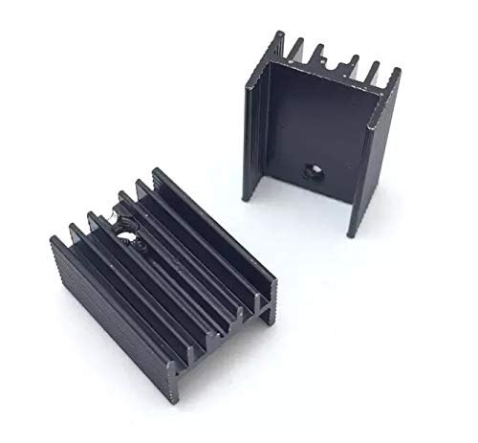A heat sink (Figure 6.6) is a component that increases the heat flow away from a hot device. It accomplishes this task by increasing the device's working surface area and the amount of low-temperature fluid that moves across its enlarged surface area. Based on each device's configuration, we find a multitude of heat sink aesthetics, design, and ultimate capabilities. The [heat transfer](https://en.wikipedia.org/wiki/Heat_transfer) from the heat sink occurs by convection of the surrounding air, conduction through the air, and [radiation](https://en.wikipedia.org/wiki/Thermal_radiation). Heat transfer by radiation is a function of both the heat-sink temperature and the temperature of the surroundings that the heat sink is optically coupled with. When both of these temperatures are on the order of 0 °C to 100 °C, the contribution of radiation compared to convection is generally small, and this factor is often neglected.

Figure 6.6: Heat Sink

**6.9 TRANSFORMER**

A transformer is defined as a passive electrical device that transfers electrical energy from one circuit to another through the process of electromagnetic induction. It is most commonly used to increase ('step up') or decrease ('step down') voltage levels between circuits. A transformer consists of two electrically isolated coils and operates on Faraday's principal of “mutual induction”, in which an EMF is induced in the transformers secondary coil by the magnetic flux generated by the voltages and currents flowing in the primary coil winding.

**Transformer Specifications**

* Input Voltage - 8V (Used input for the hardware), 12V, 16V
* Output Voltage - 240V
* kVA Rating - 250VA
* Cooling - Air cooled

**6.10 INVERTER**

The inverter is a device that converts a dc voltage into ac voltage and it consists of four switches which are connected in anti-parallel. The two switches are complementary switches which means when the first switch is ON the second switch will be OFF similarly, when the second switch is ON the first switch will be OFF.

**6.10.1 WORKING**

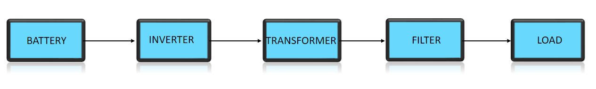

Figure 6.7: Block Diagram of the Inverter

L7805 voltage regulator converts the 12V DC to 5V DC and powers both the MOSFET drivers (IR2110) and the Arduino. The Arduino provides the switching pulses for the MOSFETs of the H-bridge. A 2.2 uF capacitor is provided in parallel to the transformer secondary to act as the filter. A feedback voltage is procured from the load end with a RC circuit and is converted to a DC voltage with help of a SMD (Surface Mount Device), which essentially is a bridge rectifier. This DC voltage is fed to the Arduino Nano and it provides the SPWM gate pulse such that the duty ratio is adjusted to meet the load demand. The block diagram of the proposed inverter is shown in Figure 6.7 and the hardware implementation of inverter with H-bridge topology is shown in Figure 6.8.

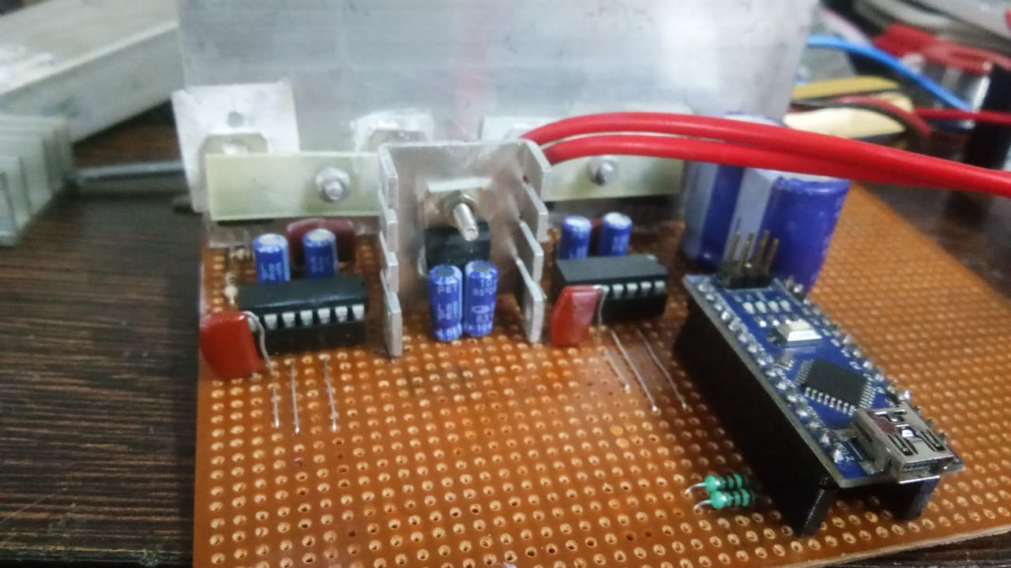

Figure 6.8: H-bridge Inverter

**6.10.2 HARDWARE IMPLEMENTATION OF INVERTER CIRCUIT**

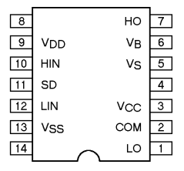The output of the battery is fed to the inverter circuit, Voltage regulator L7805, and 3rd pins of IR2110 gate drivers. The 12V of the battery is converted to 5V by the voltage regulator and it is fed to the logic pin of the Gate driver and Arduino for powering them. The gate pulses are provided by the Arduino Nano through its digital 9th and 10th pins. The Digital 9th pin of Arduino is connected to the 10th and 12th pin of first and second Gate drivers respectively, and the Digital 10th pin of Arduino is connected to the 12th and 10th pin of first and second drivers respectively.

Figure 6.9: Pin Diagram of IR2110

The gate driver acts as a buffer for Low-side MOSFETS. The 10th and 12th pin of IR2110 is the input for High-side and Low-side MOSFET. A 12V is applied to the 3rd pin of the drivers for providing a voltage which is higher than the threshold voltage across gate-source the lower MOSFETS. When the leftmost lower MOSFET conduct, the 22 $μ$ F capacitor, which is connected between the 6th and 5th pins of first diver charges. After the ON period of the Low-side MOSFET,

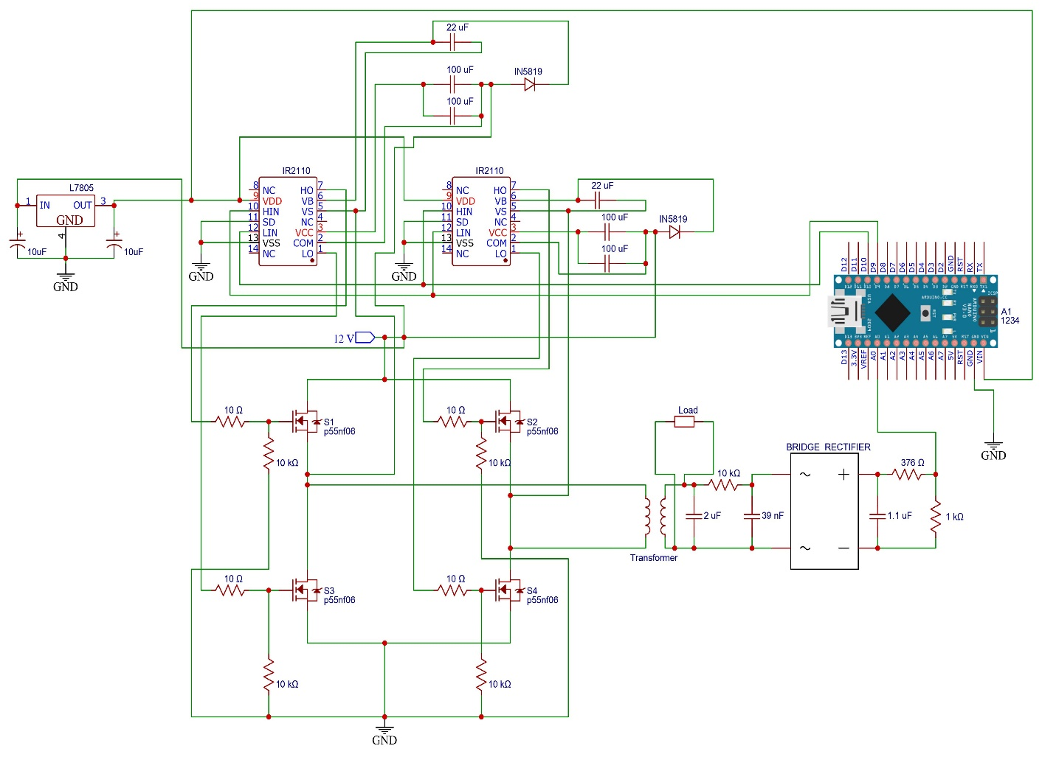 it discharges and provides an 11.3V across the gate-source terminal of the leftmost High-side MOSFET. This same process occurs for the right side MOSFETs also. The pin diagram of IR2110 is illustrated in the Figure 6.9 and circuit diagram of the hardware implemented is depicted in Figure 6.10.

Figure 6.10: Hardware Circuit Diagram

When the switch on Arduino is pressed, the gate pulses will be generated by the Arduino through the Digital 10th pin and are fed to the 12th pin of the first driver and the 10th pin of the second driver. The gate pulses on the 12th pin of the first driver will trigger the gates of S2 and S3 MOSFETs and they conduct. This produces an output across the transformer. After this cycle, the digital 10th pin of Arduino produces gate pulses and that are fed to the 10th pin of the first driver and the 12th pin of the second driver. This triggers S1 and S4 MOSFETs gate terminal. As a result, The S1 and S4 MOSFETs conduct, and an output is obtained across the transformer, which is 180° out of phase with the first cycle output. This output will not be smooth and has voltage spikes. To eliminate this distortion, this signal is passed through an LC filter and a smooth 230V sinusoidal wave is obtained. This is fed to the load.

A closed-loop circuit is designed to obtain stability in output. For this, the output of the LC filter is given to a rectifier through an RC filter. A capacitor of 39nF is placed across the rectifier to eliminate AC components that will present even after the rectification. The rectified output is passed to a voltage divider circuit and it is reduced to a voltage ranging between 0 to 5V. This output is fed to the Analog pin of Arduino. These voltage fluctuations determine the width of pulses generated by the digital pins of Arduino. This closed-loop circuitry will provide a constant 230V sinusoidal wave.

**6.10.3 TESTING THE INVERTER ON LOAD**

The duration at which the inverter discharges under load condition depends on the total power of load connected to its output terminal and the power rating of the battery connected to its input terminal. Bearing in mind that total load must not exceed 200 watts.

**Discharge duration**

(a) Battery power rating = 12 volts, 7 Ampere per hour.

If total load = 150watts,

Then, duration = (12*7)/50 = 1.68 hrs =101 minutes.

On experimentation, duration = 1.5 hrs = 90 minutes.

(b) Battery power rating = 12 Volts, 60 Ampere per hour.

When load = 300 Watts,

Then, duration = (12*7)/100 = 0.84 hrs = 51 minutes.

On experimentation, duration = 0.76 hrs = 46 minutes.

**6.11 OUTPUT**

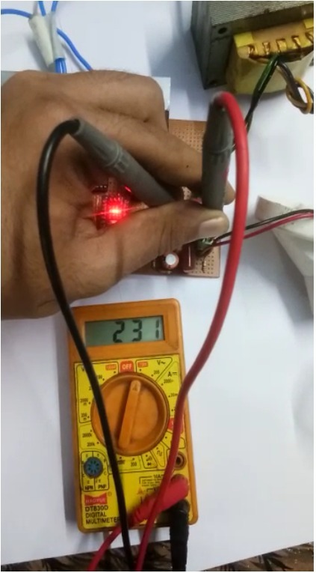An incandescent lamp was used as the load and the multimeter reading was 231V on testing as shown in the Figure 6.11. The output was taken across the terminals of the transformer secondary i.e, across the LC filter.

Figure 6.11: Load Voltage

**CHAPTER 7**

**CONCLUSIONS**

Designed and simulated the Solar Panel, Boost Converter and Inverter with Battery to meet the load requirement of 160 Watts and successfully implemented the hardware of the closed-loop inverter. The hardware part of the closed-loop inverter module is implemented by taking feedback from the voltage across the load to the Arduino module using a surface mount device. Gate pulses generated by Arduino module is varied depending upon the feedback, the duty cycle is adjusted using amplitude modulation and this will ensure a constant voltage across the load.

The efficiency of solar inverter lies in the range between 75 % and 85%, and with the MPPT technology, we can harness the maximum available power. The designed prototype is suitable for use in both urban and rural areas to meet the energy requirement or to use an emergency power source when the power supply from the grid is interrupted. Since this project is implemented using different parts, the parts can be easily dismantled, therefore, it is very portable and if any part gets faulty that can easily be replaced with little effort. In general, the whole project module has fewer components, can be easily mounted or dismounted, thus needs less maintenance.

Photovoltaic power generation is gaining significance day by day as a dependable renewable energy source considering its upper hand. The advantages include an everlasting pollution-free energy production scheme, ease of maintenance, and direct sunbeam to electricity conversion. However, the high cost of PV installations still hinders the widespread use of this technology. Moreover, the PV panel output power fluctuates depending on the weather conditions, such as the insolation level, and cell temperature. The inverter will supply an AC supply to a load from a DC source. The project described is valuable for the promising potentials it holds within, ranging from the long-run economic benefits to the important environmental protection schemes. With the increasing improvements in solar cell technologies and power electronics, this project would have more value and can act as the first step to a drastic change of using environmentally friendly fuels to supplement our never-ending energy needs.

**7.1 SCOPE FOR THE FUTURE**

Technological improvements have made solar-electric modules more cost-effective. Today that price has dropped to around 20 cents per kilowatt-hour. The cheaper rate is still more expensive than the average national price of electricity, which in 2003 was a little over 8 cents per kilowatt-hour. Other recent advances include "thin film" photovoltaic technology, a high-tech coating that converts any surface covered with the film into a solar-electric power source. Boats and RVs (road vehicles) that use the film are now on the market. High level PWM inverters can be implemented in order to get less harmonic content in the output. The pulse circuit and control circuit can be implemented together with the help of microcontrollers with digital processing capabilities. MPPT can be implemented in the control loop of push-pull and closed loop control can be done for the same.

The future work consists of making a solar tracking system based on Fuzzy Logic which could help it to improvise the efficiency and output power generated. This project can be applied to the domains given below.

1. Hybrid of MPPT with mechanical tracking will give more efficiency, project can be extended in this direction.
2. Battery output is directly utilized to feed power in the dc grid which can be used for charging electronic devices like laptop, and mobile directly.
3. By adding Wi-Fi module we can record our data in the system and optimize the data for better use.
4. Solar panel installed on urban and sub-urban areas with modified technology will help to reduce our electricity bill.
5. DC-DC running loads: DC from MPPT can be taken directly and DC load can be run. DC loads helps to consume low electricity.

**REFERENCES**

1. Y. R. Kafle, G. E. Town, X. Guochun and S. Gautam, "Performance comparison of single-phase transformerless PV inverter systems," *2017 IEEE Applied Power Electronics Conference and Exposition (APEC)*, Tampa, FL, 2017, pp. 3589-3593, doi: 10.1109/APEC.2017.7931213.
2. T. Kerekes, R. Teodorescu, P. Rodríguez, G. Vázquez and E. Aldabas, "A New High-Efficiency Single-Phase Transformerless PV Inverter Topology," in *IEEE Transactions on Industrial Electronics*, vol. 58, no. 1, pp. 184-191, Jan. 2011, doi: 10.1109/TIE.2009.2024092.
3. M. N. H. Khan, M. Forouzesh, Y. P. Siwakoti, L. Li, T. Kerekes and F. Blaabjerg, "A Classification of Single-Phase Transformerless Inverter Topologies for Photovoltaic Applications," *2018 IEEE Region Ten Symposium (Tensymp)*, Sydney, Australia, 2018, pp. 174-179, doi: 10.1109/TENCONSpring.2018.8692013.
4. D. K. Dileep and K. R. Bharath, "A Brief Study of Solar Home Inverters," *2018 International Conference on Control, Power, Communication and Computing Technologies (ICCPCCT)*, Kannur, 2018, pp. 334-339, doi: 10.1109/ICCPCCT.2018.8574265.
5. K. A. Sunitha , G Prem Kumar, Nidhi Priya and Jatin Verma, “Design of High Efficient MPPT Solar Inverter(2017)”, MATEC Web of Conferences 10 , DOI: 10.1051/ 710.
6. S. Dhar, R. Sridhar and G. Mathew, "Implementation of PV cell based standalone solar power system employing incremental conductance MPPT algorithm," 2013 International Conference on Circuits, Power and Computing Technologies (ICCPCT), 2013, pp. 356-361, doi: 10.1109/ICCPCT.2013.6528926.
7. O. Pop, G. Chindris and A. Dulf, "Using DSP technology for true sine PWM generators for power inverters," 27th International Spring Seminar on Electronics Technology: Meeting the Challenges of Electronics Technology Progress, 2004., 2004, pp. 141-146 vol.1, doi: 10.1109/ISSE.2004.1490394..

**APPENDIX-I**

**TABLE-V**

**COMPONENTS REQUIRED**

|  |  |  |
| --- | --- | --- |
| **Sl. No.** | **COMPONENTS** | **SPECIFICATIONS** |
| 1 | PV Module | 187W, 9.5V and 20.4 A |
| 2 | Boost Converter | 12V (Output) |
| 3 | Lead Acid Battery | 12V |
| 4 | MOSFET - P55nf06 | 50A, VDS = 60V, VGS = +-20V |
| 5 | Transformer | 8/240V, 1 Phase |
| 6 | LC Filter | 4.62 H, 2.19µF |
| 7 | Load Power | 160 Watts |
| 8 | Load Voltage | 240V AC |
| 9 | Voltage Regulator L7805 | 12/5V DC |
| 10 | MOSFET Gate Driver- IR2110 | Vin (+-0.3V), Vout (10 - 20V), Voffset = 500V |
| 11 | Surface Mount Device – 1075DB | 2.5 x 2.0 mm |
| 12 | Arduino Nano | 12 V, 40mA, 30 pins |
| 13 | Arduino Uno | 12 V, 40 mA, 32 pins |
| 14 | Resistors | 100K , 320K, 56K , 1 K |
| 15 | Capacitors | 39nF, 1µF, 2.2µF |

**APPENDIX-II**

**ARDUINO PROGRAM FOR GATE DRIVER CIRCUIT AND FEEDBACK**

//inverter variable

// Fsw=20;// switching frequency in KHZ

//Fout=50;//fundamental o/p frequency 50hz (applied correction)

//(Fsw/Fout)*1000*0.5;//no of samples per half cycles

uint8_t i,samples=200;

uint8_t oldSREG;

bool flag=1;

volatile float MI=0.0,m,M;//Modulation Index 0<MI<1

int sineLookup[202];// value should be greater than or equal to no. of (samples+1)

int TOP_VALUE=398;// (16.0*0.5*1E3)/(1*Fsw);//1 is the clk prescalar

//END

bool softstart=0;

long t0=0;

//PID variables

const int ref=368;

int feed,err;

float ctrl;

float Gp,Gi,Gd;

const float Kp=30,Ki=5,Kd= 0;

int Cum_err=0,deltaErr=0,prv_err=0,Max_cum=250;

int Min_cum=-1*Max_cum;

int x;

#include<wiring_private.h>

void setup()

{

softstart=0;

Serial.begin(250000);

analogReference(INTERNAL);

DDRB|=(1<<PB1)|(1<<PB2); //SettingDigital Pin9 and 10 as SPWM output

float angles;

for(i=0;i<200;i++)// Generating sine values

{

angles=(float)((180.0/samples)*(i));

sineLookup[i+1]=(TOP_VALUE*sin((angles*22)/(7*180)));

}

i=0;

sbi(ADCSRA,ADPS2);

cbi(ADCSRA,ADPS1);

cbi(ADCSRA,ADPS0);

inverter();

}

void loop()

{ Serial.println(x);

if(micros()-t0>=1000)

{

//Serial.println(micros()-t0);

feed=analogRead(A0);//0-1023

err=ref-feed;

//proportional part

Gp=Kp*err;

//integral part

Cum_err+=err;

if(Cum_err>Max_cum)

{

Cum_err=Max_cum;

}

else if(Cum_err<(Min_cum))

{

Cum_err=Min_cum;

}

else{

Gi=Ki*Cum_err;

}

//derivative part

deltaErr=err-prv_err;

Gd=Kd*deltaErr;

prv_err=err;

//End

//Control signal,

ctrl=(Gp+Gi+Gd);

//limits to control

if(ctrl<0){ctrl=0;}

if(ctrl>=1500){ctrl=1500;}

if(softstart==0)

{

m=ctrl/1579.0;

}

else MI=ctrl/1579.0;

t0=micros();

}

//softstart

while(MI<(m))

{ MI+=0.01;

delay(20);}

if(MI>(m)&&softstart==0)

{ MI=m;

m=0.0;

softstart=1;}

}

void inverter()

{

oldSREG=SREG;

cli();

//CONFIGURING TIMER REGISTERS

TCCR1A=0;

TCCR1B=0;

TCCR1A|=(1<<COM1A1)|(1<<COM1B1);//PHASE CORRECT PWM

TCCR1B|=(1<<CS10)|(1<<WGM13);//PRESCALAR

ICR1=TOP_VALUE;// DEFINING TOP VALUE

TIMSK1|=(1<<TOIE1); // ENABLING OVERFLOW INTERRUPT

//END

SREG=oldSREG;

}

ISR(TIMER1_OVF_vect)

{

if(i==0)

{flag=!flag;

}

if(flag==0)

{

OCR1A=M*sineLookup[i+1];

OCR1B=0;

/*if(i==200) {

if(analogRead(A2)>500)

}*/

}

if(flag==1)

{

OCR1B=M*sineLookup[i+1];

OCR1A=0;

if(i==200) {M=MI;}

}

i++;

if(i==201) i=0;

}

**APPENDIX III**

**MPPT ALGORITHM**

function duty = MPPT_algorithm(vpv,ipv,delta)

% I used the MPPT algorithm in the MATLAB examples

% I only modify somethings.

duty_init = 0.1;

% min and max value are used to limit duty between

% 0 and 0.85

duty_min=0;

duty_max=0.85;

persistent Vold Pold duty_old;

% persistent variable type can be store the data

% we need the old data by obtain difference

% between old and new value

if isempty(Vold)

Vold=0;

Pold=0;

duty_old=duty_init;

end

P= vpv*ipv; % power

dV= vpv - Vold; % difference between old and new voltage

dP= P - Pold;% difference between old and new power

% the algorithm in below search the dP/dV=0

% if the derivative equal to zero

% duty will not change

% if old and new power not equal

% &

% pv voltage bigger than 30V

% the algorithm will works

if dP ~= 0 && vpv>30

if dP < 0

if dV < 0

duty = duty_old - delta;

else

duty = duty_old + delta;

end

else

if dV < 0

duty = duty_old + delta;

else

duty = duty_old - delta;

end

end

else

duty = duty_old;

end

%the below if limits the duty between min and max

if duty >= duty_max

duty=duty_max;

elseif duty<duty_min

duty=duty_min;

end

% stored data

duty_old=duty;

Vold=vpv;

Pold=P;

**APPENDIX IV**

**CASE STUDIES**

Some implementation of solar power and MPPT in different areas and fields are:

1. Nigeria has an abundant amount of solar energy made up of about thirty percent diffused radiation and seventy percent direct radiation. The theoretical energy available yearly in Nigeria is about 500,000 GWh. The average duration of sunshine varies from a minimum of 5.3 hours per day in the cloudy forest region to about 7.7 hours per day in the dry savannah region. Nigeria’s average peak sun hours varies from 5.0 to 5.7 peak sun hours with Lagos having average peak sun hours of 4.5. The major challenges with the utilization of Nigeria’s abundant solar resource has been the high cost of installation and the lack of technical expertise on some sectors like the grid connected sector of the solar industry.
2. Electric Rickshaw from Sukam runs by the solar power. Ordinary battery rickshaw uses electricity from conventional form to charge the battery (takes 2-3 hours), but Solar rickshaw runs by the Sun. It gives 20 km more average than an ordinary rickshaw. Using MPPT technique, at first the MPPT Controllers converts the achieved voltage into regular voltage of need, and then the remaining excess/extra amount of voltage is converted into Amp. Due to this, the level of charged voltage in the battery is kept at an optimal point, which helps to reduce the required time for charging.
3. Envision Solar, California, has been awarded contract in California to provide portable EV (Electric Vehicle) chargers. They made the PV panels on the upper side of parking area, where the Vehicles can be charged and provides 150 miles of range in a day. MPPT technologies are used in electric vehicles for fast charging.

**APPENDIX V**

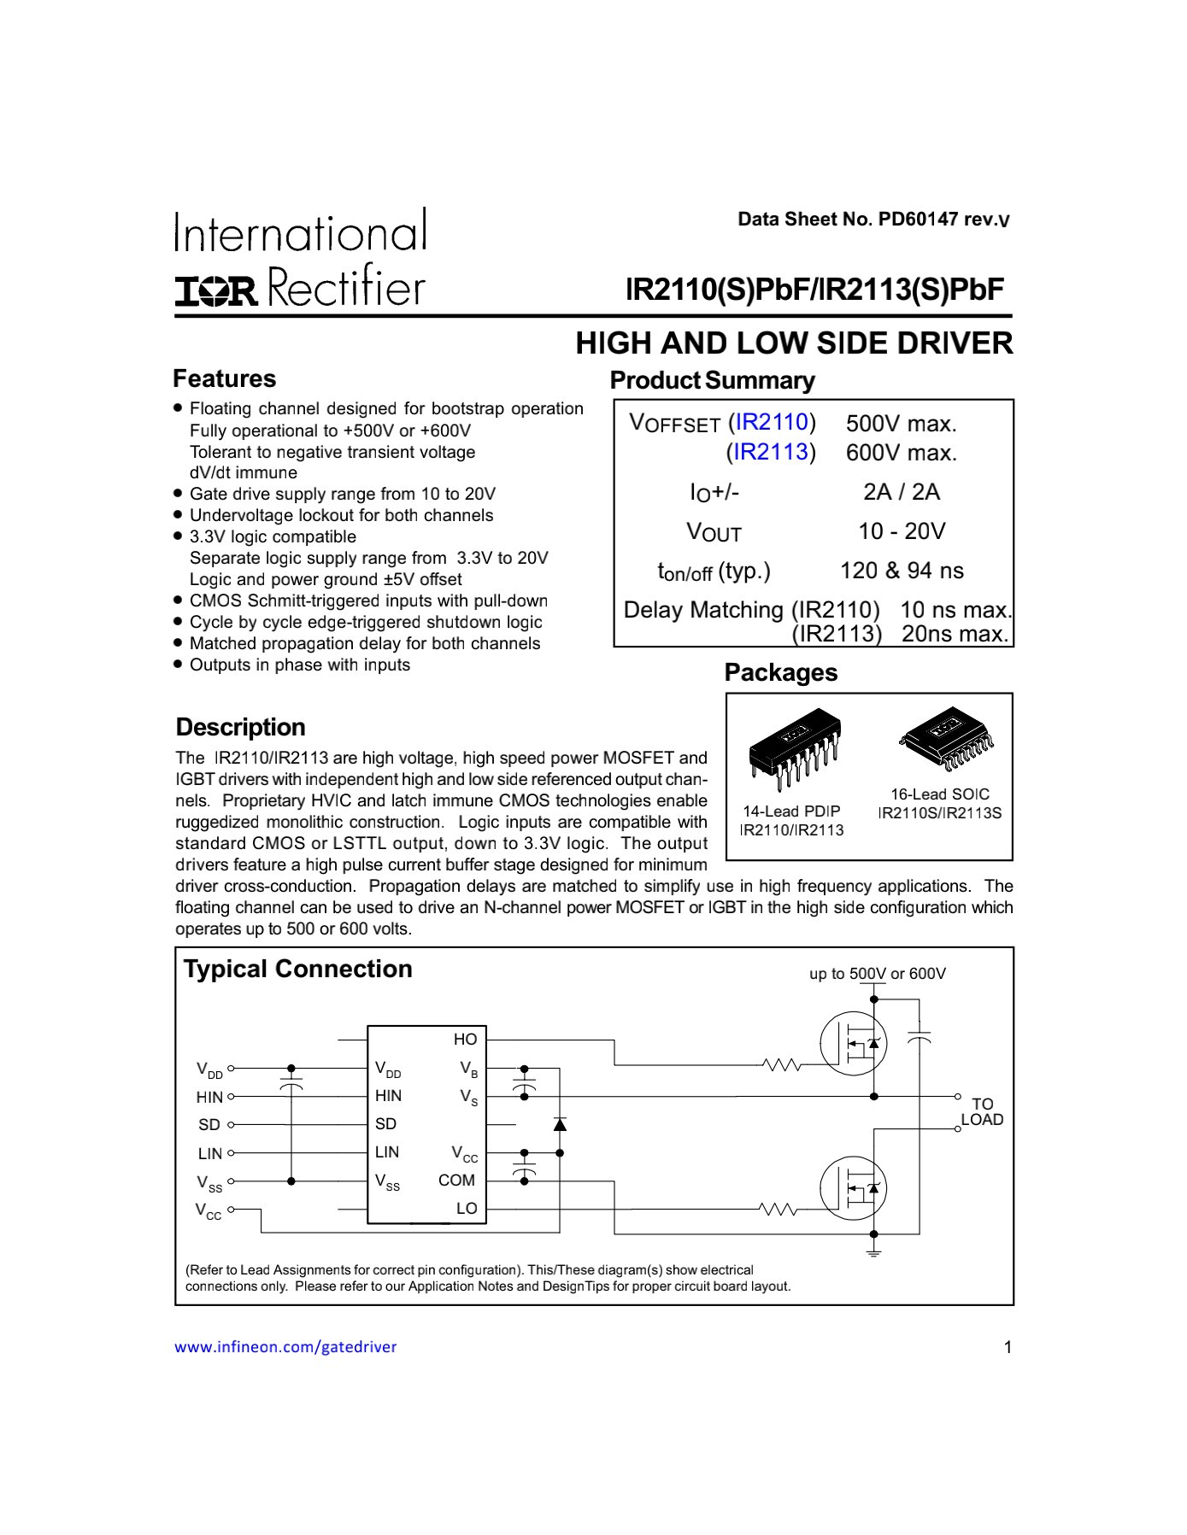

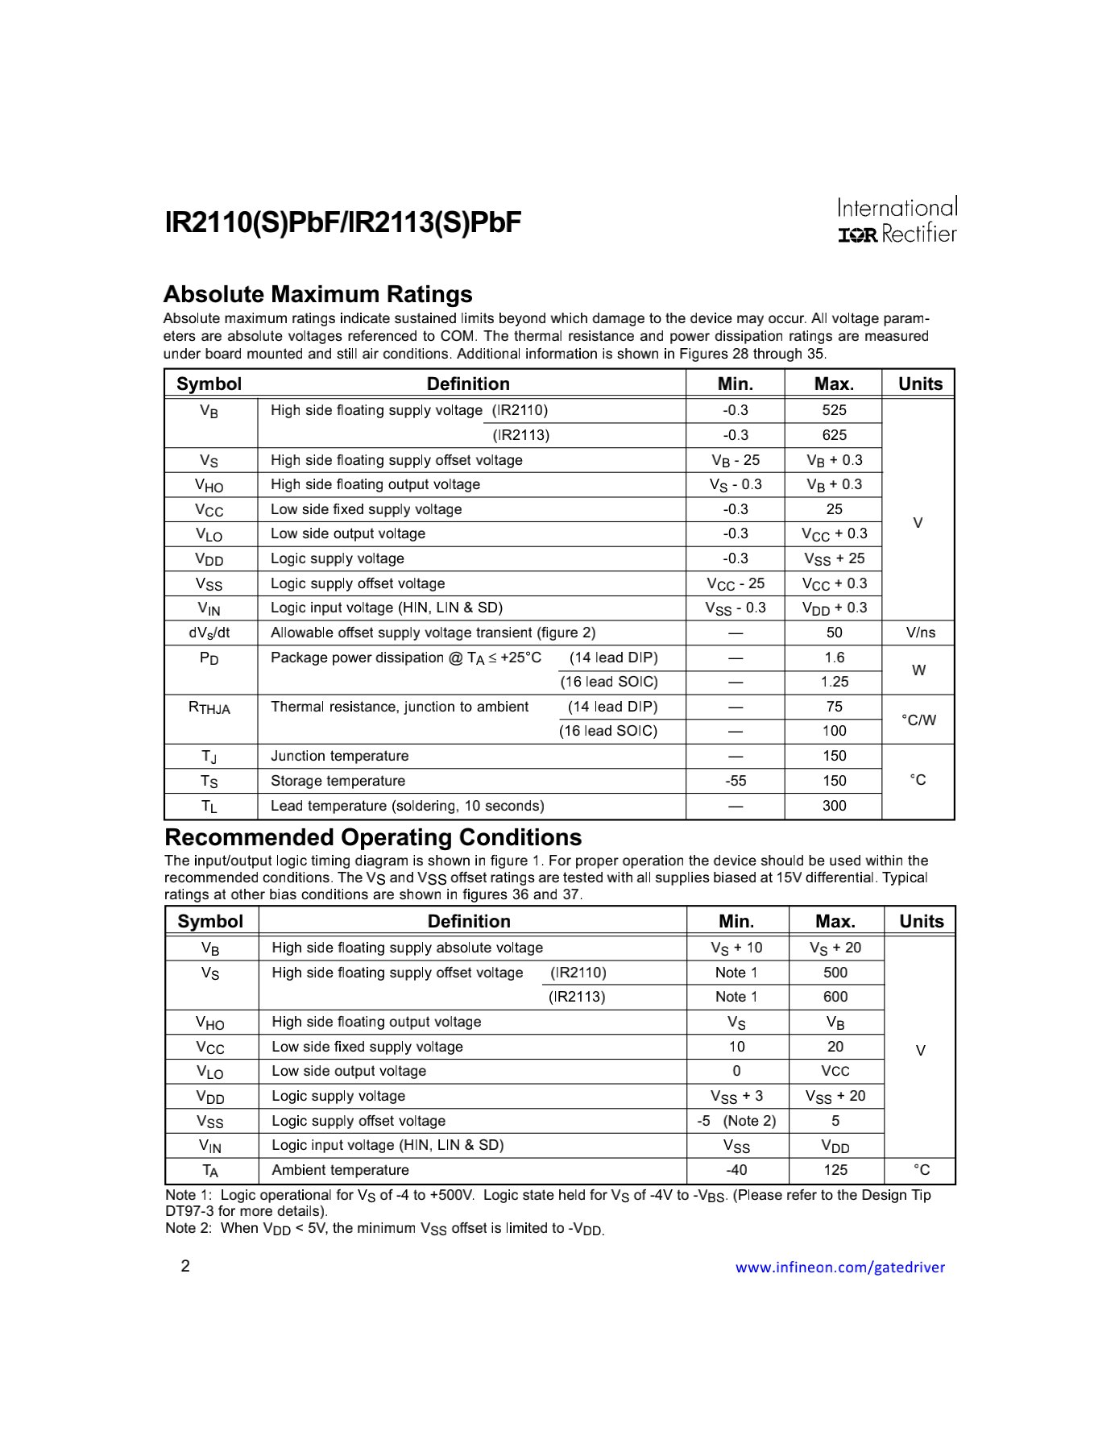

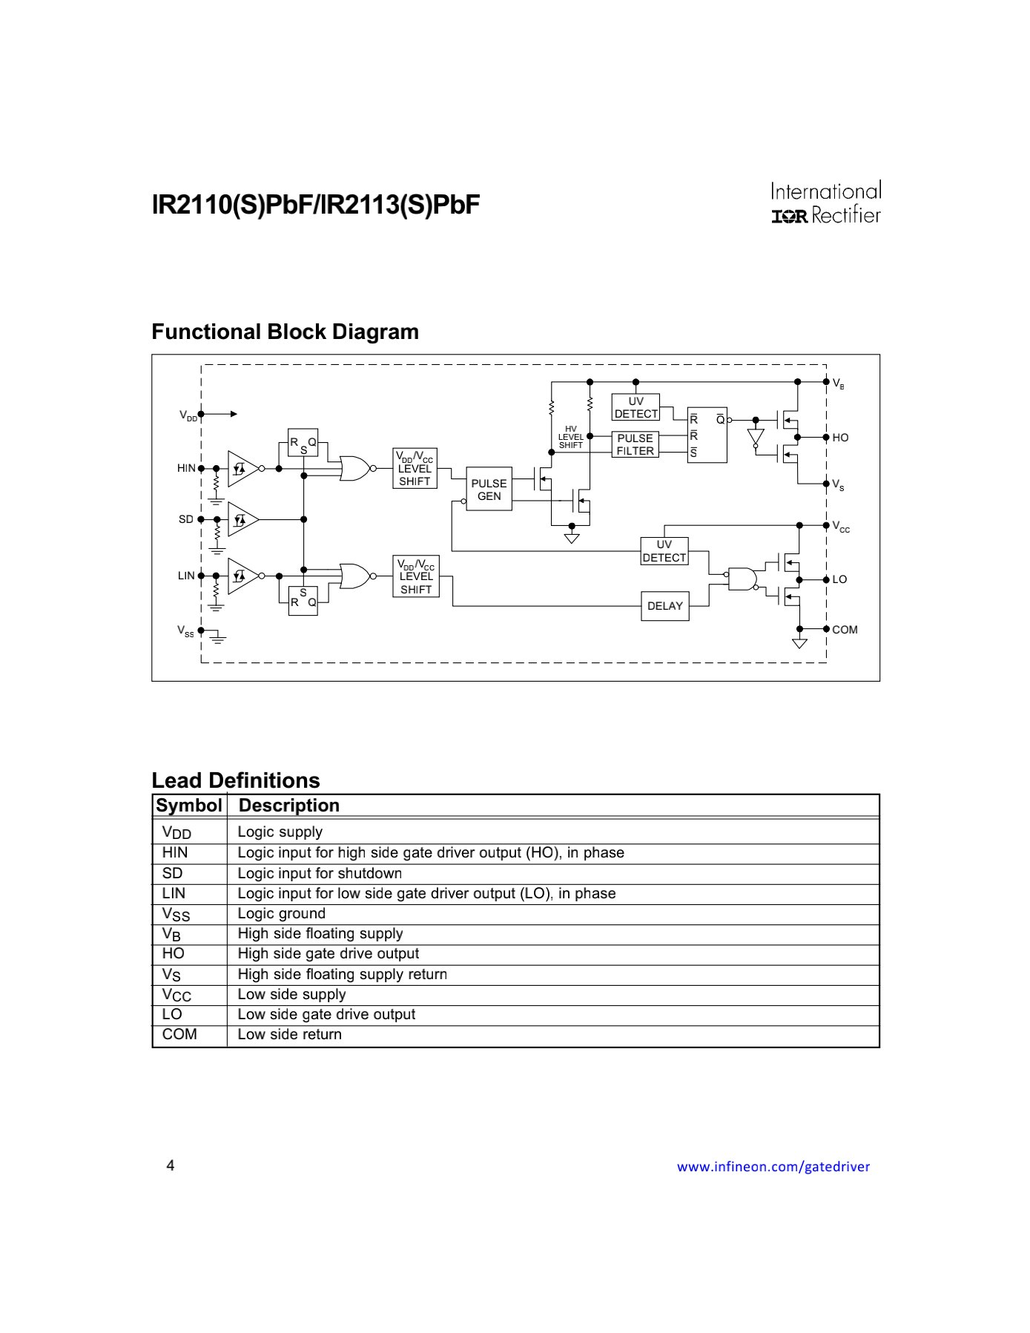

**APPENDIX VI**

